URAVAN SUPPLY PO Box 45 Naturita, CO 81422

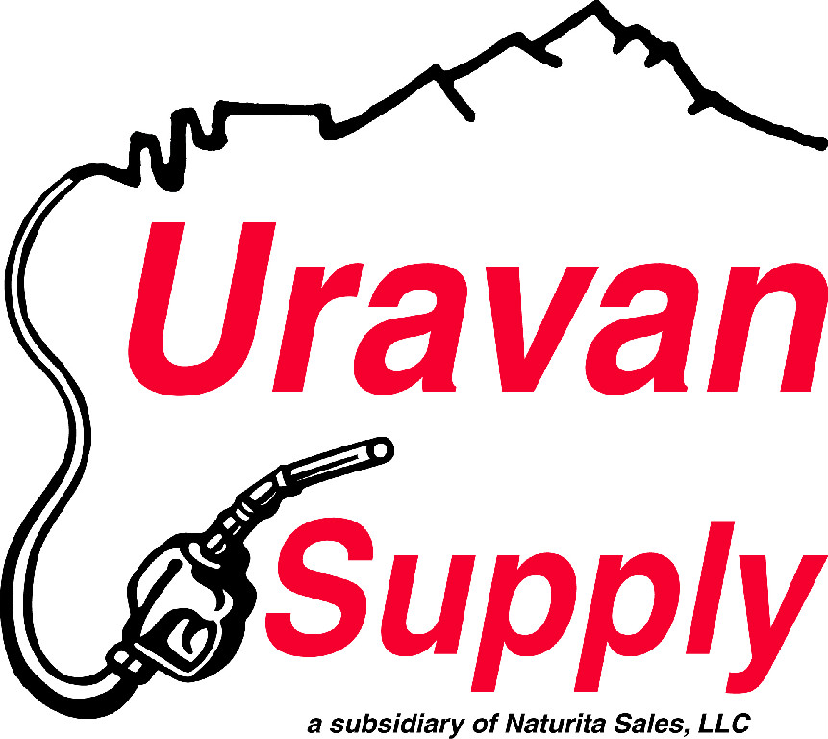BUSINESS CREDIT APPLICATION Phone 970.865.2588 Fax 970.865.2587

# BUSINESS CONTACT INFORMATION

|  |  |  |
| --- | --- | --- |
| Contact Person/Title |  | Date business commenced: |
| Company name |  | Taxable |
| Phone | Fax |  | Non-Taxable (Please attached license copy) |
| E-mail |  | Resale/Tax Exempt # |
| Registered company addressCity, State ZIP Code (mailing) |  | FEIN #: |
| Business location (physical) |  | How long at current address? |

# BANKING/CREDIT INFORMATION

|  |  |  |  |
| --- | --- | --- | --- |
| Bank name |  | City, State ZIP Code |  |
| Phone |  | Type of account | Savings  Checking  Other |
| Fax |  | Account number |  |
| E-mail |  | Account number |  |

# BUSINESS/TRADE REFERENCES

|  |  |  |  |
| --- | --- | --- | --- |
| Company name |  | Phone |  |
| Address |  | Fax |  |
| City, State ZIP Code |  | E-mail |  |
| Type of account |  | Other |  |
| Company name |  | Phone |  |
| Address |  | Fax |  |
| City, State ZIP Code |  | E-mail |  |
| Type of account |  | Other |  |
| Company name |  | Phone |  |
| Address |  | Fax |  |
| City, State ZIP Code |  | E-mail |  |
| Type of account |  | Other |  |

# agreement

1. All invoices are due and payable on or before the 10th of the month, following the month of purchase. On the 15th day, the account will become delinquent and interest charge of 2% per month or an annual percentage rate (ARP) of 24% will be charged and added to the account.
2. Claims arising from invoice/statement must be made within seven working days.
3. I accept full responsibility for all charges incurred on this account, until card(s) are returned or written notice is given by me to close the account. I understand there is no initial fee for the card(s); however, if I need a card replaced, there will be a $5.00 charge. If collection action is required, I agree to pay reasonable attorney’s fees, court costs, collection fees and etc., if collection becomes necessary to settle my account.
4. By submitting this application, you authorize URAVAN SUPPLY to make inquiries into the banking and business/trade references that you have supplied.

# SIGNATURES

|  |  |  |  |
| --- | --- | --- | --- |
| Signature |  | Signature |  |
| Name and Title |  | Name and Title |  |
| Date |  | Date |  |