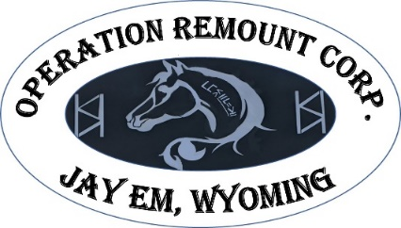
)
The Operation Remount Corporation &
The Wyoming Mustang Association (WMA)
2026 Spring Rendezvous
Saturday, June 6th
Indoor Arena, Goshen County Fairgrounds
Registration begins at 8:00am, Event begins at 9:00 am

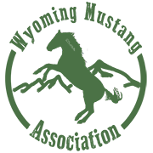

Exhibitor Number: WMA Member: Yes No
Name: Email: Phone Number:
Address: City: State: Zip: Horse/Burro/Mule Name:
Class/Division Selection

Under Saddle Walk/Trot* Youth (12 and Under)** In Hand/Burro ***
Showmanship Showmanship Showmanship Showmanship
Western Pleasure Western Pleasure Western Pleasure Equitation
Western Equitation Western Equitation Western Equitation Extended Equitation
Simple Reining Simple Reining Simple Reining Challenge Trail
Challenge Trail Challenge Trail Challenge Trail

* Walk/Trot is open to all aged riders, entrants in this division cannot enter into the other divisions with the same animal.
** Competitors entered in the Youth division will be asked to lope.
***The division includes horses and burros is a single “In Hand” division ONLY.
Make checks payable to the Wyoming Mustang Association or WMA. Early entries and payments can be mailed to:
WMA
PO BOX 2125
Cheyenne, WY 82003-2125
Registration: Early Entries taken until May 31, 2024
WMA Member # of Classes Entered: X $10.00 =
Non-Member # of Classes Entered: X $15.00 =
Cowboy Challenge Trail Entry Fee $25.00 =

Office Fee $10.00 =

Total Entry Fees:

NO REFUNDS OR CREDITS FOR SCRATCHED CLASSES!

I, (therein after “the participant”), acknowledge individually or on behalf of my minor child of which I am the parent or legal guardian, that while riding/participating in WMA events there are inherent risks associated with equine activities and hereby voluntarily assume all risks, known and unknown, foreseen and unforeseen. The Wyoming Recreational Safety Act (WY Stat. Ann1-121 et seq (2000), which limits the liability for risks in sports and recreational opportunities is, by this reference, incorporated into any General Release and shall be considered an integral part hereof.

In addition to assuming all inherent risks as stated above, the Rider hereby agrees that he/she shall irrevocably and forever release and discharge the WMA, it’s officers, directors, volunteers, and members (hereinafter collectively known as “Released Parties”) from any and all liability of any kind whatsoever, including without limitation, any damages resulting from the Released Parties’ acts of negligence, and from all legal claims or legal liability of any kind, nature and description, present or future, involving or relating to property damage, bodily injury or death suffered or sustained as a result of engaging in or any way arising out of participation in any events.

The Rider/Participant agrees to defend, at his/her own expense, and to indemnify and hold harmless the Released Parties from any and all claims and demands brought against them or their participants related in any way to or arising out of the participation in any events, including actions based on the negligence of the Released Parties or Rider, including all costs and attorney’s fees incurred by the Released Parties in enforcing this general release.

Signature of Participant (or parent/legal guardian if under age eighteen) Date

