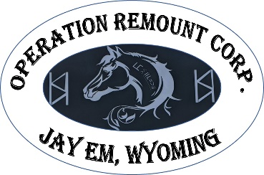
Mustangs for Veterans or First Responders

APPLICATION
12080 US Hwy 85 • Jay Em, Wy 82219 • (308)-224-4694 • kelly@operationremount.org
Participation in this program is by invitation only; therefore, the Board of Trustees has the unqualified right to determine eligibility and can, at any time, remove a participant from the Operation Remount program for any or no reason at all. Military veterans and first responders are eligible to participate in this program.

APPLICANT INFORMATION:

* Name: ___________________________________________________ *Birthdate: _________________

*Mailing Address: ______________________________________________________________________

*City/State/Zip: ________________________________________________________________________

*Phone: __________________________________ *Phone 2: ___________________________________

*Email Address: _______________________________________________________________________

*Emergency Contact: ______________________________________ *Phone: _____________________

VETERANS & MUSTANGS QUESTIONAIRRE:
All questions must be completed.
What branch of the Military did you serve in? OR What first responder capacity (police, fire, ambulance, etc?) ________________________________________________________________________________
Military Occupation (MOS) _______________________________________________________________
Are there any medications, triggers, or environmental considerations that should be made known?
____________________________________________________________________________________
_____________________________________________________________________________________
Do you have any medical conditions (heart, lung, physical, etc) that would prevent you from physical activity such as pushing, pulling, squatting, lifting carrying, walking? If Yes, please explain.
____________________________________________________________________________________
_____________________________________________________________________________________
Do you have any food or environmental allergies? If yes, please list. ______________________________
_____________________________________________________________________________________

Have you trained a horse before? If yes, tell us about your experience: _____________________________________________________________________________________
_____________________________________________________________________________________
_____________________________________________________________________________________
Why should you be chosen for the program?

If chosen for the program what would be your perfect mustang? (Gender, color, etc).
__________________________________________________________________________________________________________________________________________________________________________

Applicant’s Signature: __________________________________ Date: ____________________

*Please attach DD214 to application (If applies)

Please send application/documents to:

kelly@operationremount.org

OR

Mirrored K Legacy Ranch
Operation Remount
c/o Kelly Alexander
12080 US Hwy 85
Jay Em, Wy 82219

