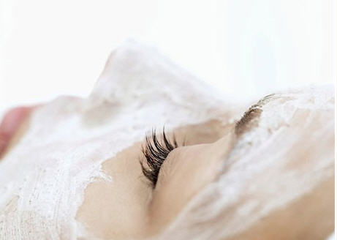
Here are the five benefits

of using a face mask:
- Refines skin pores: Face mask can help you to get clearer skin and more refined pores. It deep cleanses the pores and clears the pores of dead skin cells, metabolic wastes and the oily substances that can clog them.
- Increases hydration: Face mask can also bring moisture and hydration to dry and dehydrated skin types. The water from the mask penetrates deep into the skin epidermis to soften the skin and enhance its elasticity. When the skin is hydrated and well moisturized, it becomes easy to apply proper makeup. Also it gives a more plump and youthful appearance to the skin.
- Diminishes fine lines: Regular use of face masks can reduce the signs of aging like fine lines, wrinkles, and brown spots and so on. Also you will get to enjoy a softer and smoother skin texture.
- Gives even skin tone: Face masks are also designed to diminish hyper-pigmentation and give you more even skin tone and texture. It also promotes the sweat gland secretion so as to increase the oxygen content of the skin.
- Firmer skin: Loose skin can make you look older than your age. The problem of loose skin can be easily solved with regular use of face masks. There are certain types of face masks that help to enhance collagen production and fight off free radical damage which will gradually result in firmer, tighter, fresher looking skin.

Apart from the above mentioned skin benefits, applying a face mask also helps you to relax. You get the time to relax, while your face mask is working. This will help you to de-stress and that alone can make you look and feel better!

Usually a facial mask product is to be used for a short period of time on the face. It takes only a few minutes to apply, and then you just have to wait for 15 to 20 minutes and then wash it off. The process of applying a face mask is simple and easy and it gives you immense benefits.

Check out Soaps and Such SPA Face Masks that incorporate skin loving oil with nourishing extracts designed to bring out these benefits for each skin type. More information on these masks and to consider purchasing online:
https://soapsandsuchalpena.com/shop?keywords=spa%20facial&olsPage=search&page=2

