What is an Essential Oil? And What Do They Do?
We spent over $374 BILLION dollars in healthcare in 2014. Per person, we spend 40% more than any other nation. And if you take into account the entire medical industry the number is simply staggering: $3.8 Trillion dollars. (Yes, that's with a “T”!)
That’s more than the entire Gross Domestic Product for 87% of the countries of the world! And yet, despite spending all that money, America is still ranked 17th in terms of quality of health.
So why am I bringing this up? After all, you’re here to learn about essential oils, right? You bet your little tushy you are. I bring these figures up because if you’re like the majority of Americans, you know (deep down inside) that there is a better way to health. A more natural way to health.

Did You Know?
The bottoms of our feet contain some of our largest pores, along with many reflex points and nerve endings, making them a popular and effective area for topical oil application.
If you have sore or aching muscles, add 1-2 drops of Peppermint to a carrier oil, such as coconut oil, and massage onto your feet.

The Most Powerful Forms Of Healing Are Found Right Here On God’s Green Earth.

Mother Nature knows more than humans will ever know. And she provides everything we could ever need to maintain vibrant health well into our mature years.
And I don’t care what the “officials” say – something made from chemicals in a lab will never work better than what Mother Nature can come up with. The irony is… most of the treatments are created in a lab today is just trying to duplicate what Nature already does.
So why do companies spend decades… and billions of dollars… doing this? Simple: You can’t patent a plant or natural process. And if you can’t patent it… you can’t make money!
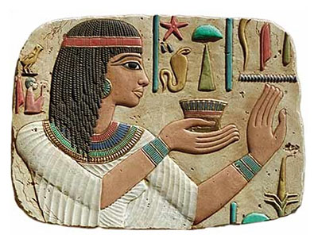
Essential oils are today’s natural miracle remedies… yet the practice of using essential oils has been around for thousands of years.
In fact, using essential oils dates back to the ancient Egyptians. And in many ancient texts the oils were often referred to as “nectar of the Gods.”
There are also over 500 references to essential oils in the Bible. Obviously these miracles of Mother Nature were highly revered by Ancient Man.
When I first learned about Essential Oils my first thought was “how could something so simple actually improve my health?” But as I did more research and learned how they really work, I was amazed.
So the purpose of this article is to share with you information on Essential Oils that can help you make wise choices. Especially as you consider incorporating them into your life to improve your health and well being.

What are Essential Oils?

Essential oils have become a bit of a “buzz” word that a lot of people talk about. Yet, if you ask someone “what are essential oils”… you’ll get a different answer every time!
So let’s dive into a quick examination of just what exactly they are.
You can consider essential oils as the “life blood” of a plant. They circulate through all the plant tissue and carry nutrition into the cells and waste products out. Thus, the “essential” part… without them, the plant would die!
Here’s the interesting thing: when high quality essential oils are applied to your skin, they do many of the same tasks as they do while inside the plant. They quickly permeate the cell walls of your skin to deliver nutrition and remove waste.
As they do this, they help to clean the receptor sites of your cells… receptors that are easily disrupted by heavy metals and petrochemicals (the chemicals found in plastic).
This cleansing effect helps to restore balance to your body, which ultimately helps you to feel better.

Not All Essential Oils Are Created Equal

Notice I said high quality essential oils. That’s because not all oils are created equal. There are three types of essential oil: fragrance, food and high quality oils.
95% of all essential oils are made for the food and fragrance industry. There are hundreds of compounds in just one essential oil, but not all oils are used for healing purposes.
The fragrance industry is just interested in the nice smell. So in a lab they remove only the part of the oil that gives the smell and they throw the rest out.
The food industry just wants the parts that taste good. So in a lab the take out the ingredients that taste like mint, peppermint, cinnamon, etc., and use small amounts to flavor the things they make.
With high quality oils, all of the compounds are left in tact so that you can experience the fully health benefits that Mother Nature intended.

When “Natural” Isn’t Natural at All

Here’s where things get really fun…
Most of us are becoming savvy shoppers who read the labels for the food we buy. Words like “organic”, “sugar-free” and “all natural” are signs we look for that indicate that food is healthier for us.
Yet the government allows anyone to use the word “natural” on a product if… read very carefully now… the compounds that make up the product COULD be produced in nature!
Read that again. This means that even if the product is 100% man-made in a lab from synthetic materials, yet it could have been made of natural ingredients, then it can be labeled as “natural.”

Oils That Heal & Oils That Don’t

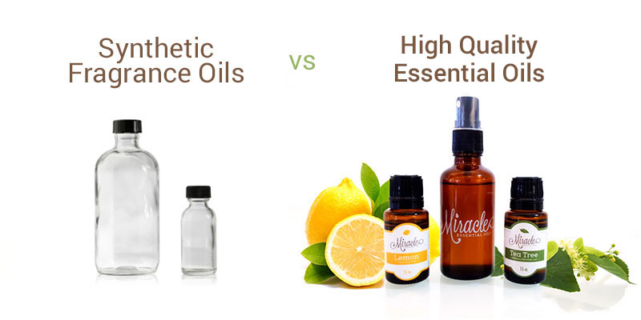
Real high quality essential oils can promote restoration and provide balance to all of your body’s systems.
Synthetic oils do not.
How can you tell the difference?

The type of bottle is your first clue: REAL essential oils are stored in dark bottles with a label that shows all the ingredients, including the botanical name.
Synthetic oils come in clear bottles, do not show the ingredients or if they do, don’t list the botanical name and have absolutely no healing property at all.
Your second clue is the price: Real essential oils cost more. And for many people, the higher price is a turn off. Yet what do you prefer? Mother Nature’s pure remedy… or synthetic garbage?

What is GC/MS testing?
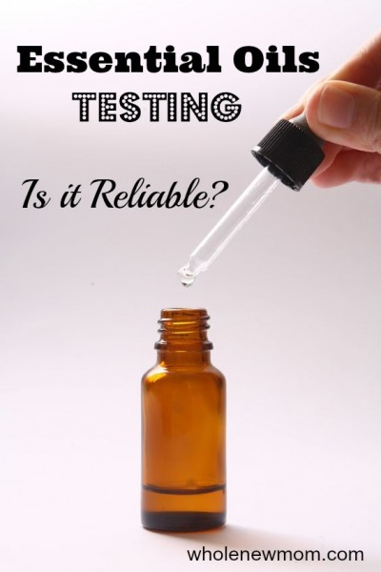
GC/MS testing is Gas chromatography–mass spectrometry. What does that mean, you ask?
Basically, here’s what a GC/MS test does:
1. The essential oils are injected into an apparatus with a tube. The tube is coated with material that has different affinities for different chemicals at different temperatures.
2. The temperature of the apparatus is gradually increased.
3. The oil vapors are moved through the apparatus to a detector at the end of the column.
4. The detector responds to the vaporized parts of the oils by printing out proportional peaks on paper.
5. The height of each peak corresponds to the amount of each component of the oil.
6. Components are identified by the time at which the peak prints out on the paper.
7. The data for each oil can be compared with standards, or “fingerprints,” for each essential oil to make determinations about purity and other qualities about the oil.

How To Use Essential Oils

When you’re just getting started, one of the most confusing aspects of essential oils is how to use them.
There are really only three basic ways:
1. Smell them 2. Apply them 3. Eat them
Using the fragrance of Real essential oils has been documented for eons. It’s how most people are introduced to them.
So when it comes to smelling them, you have a couple of options: you can put a few drops in your hand and smell them directly; or you can put them in a special device called a diffuser that sprays a fine mist into the air.
Diffusing is a great way to keep any room smelling fresh and vibrant all day long. One not on this, since oils and water don’t mix, the oil actually sits on top of the water (even if you mix it). At Soaps ad Such you can buy a bottle of “Mixing Solution” that will mix your oils & water together for the full benefit of continuous diffusing.
The other two are pretty self-explanatory: you can rub them on your body or you can eat them.
Be warned: Some oils are very powerful and if you rub them directly onto your skin, you may break out in a rash. ALL essential oils should be mixed with a carrier oil or fluid of some type. Remember…what goes on your skin goes in your body.
And when I say “eat” them – most people just put a few drops in their favorite beverage or on their food. Note: I do not recommend this at all. Why? Because the oil is concentrates on top of the water even if you mix it because oil and water do not mix. What I do suggest is that you use the real juice (example: Use lemon juice not ingest lemon essential oil).
That’s the basics on essential oils. At Soaps and Such, we provide the education on our therapeutic grade essential oils. As well, we provide you with education about how the products work. At Soaps and Such, what makes us different is that we educate people on the ingredients in the product, provide free educational literature, and stand behind what’s on the label. We have a reputation to uphold…naturally!

