. Hair Conditioner
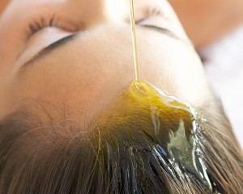Argan oil is proven to make hair softer, silkier and shinier. It is the ideal hair conditioner, and it can even help to treat split ends and tame frizzy hair. Using argan oil to condition your hair is extremely easy. It comes in several types of applications and products and has so many ways to use it for different results that we decided to write an in-depth guide to using Argan oil for hair.
3. Sleek and Shine Styling
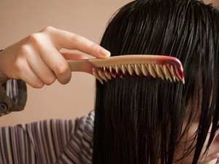Due to its ability to tame frizz and give hair shine, argan oil is also commonly used as a styling agent. It makes hair more manageable and adds a healthy, attractive shine to any hair style. This is an ideal step to add to your daily routine after blow-drying. Rub a few drops of argan oil over your palms and then comb your fingers through your hair to apply.

