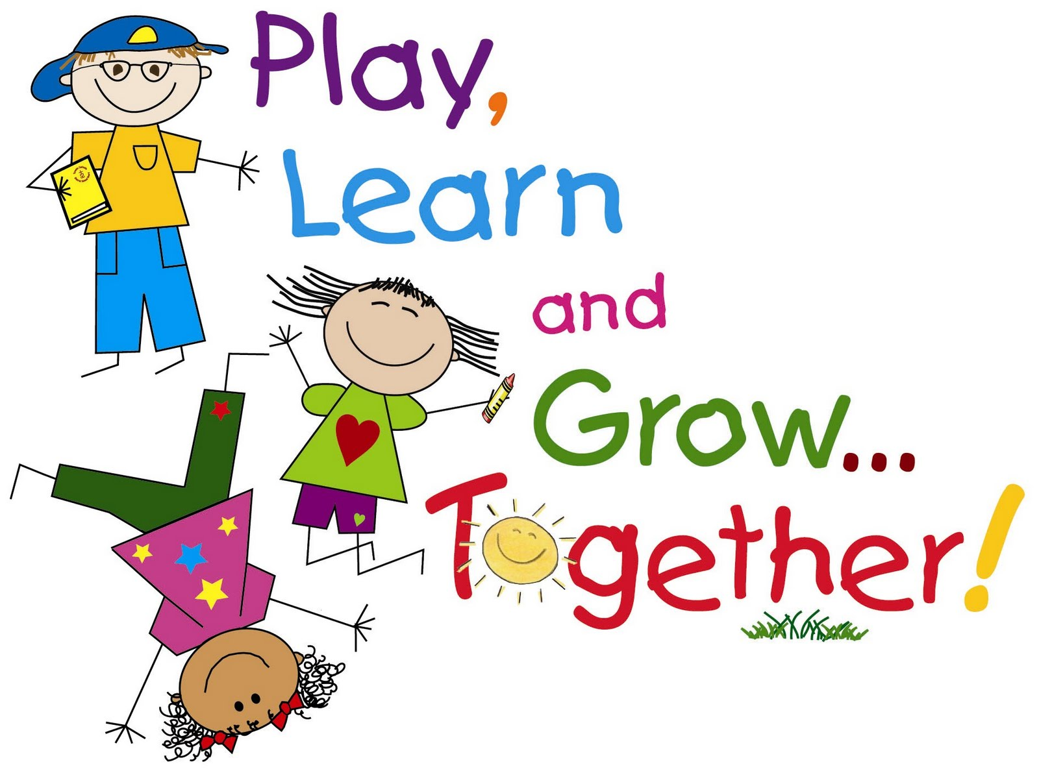

Preschool Curriculum

Our preschool curriculum is centered around the High Scope curriculum. High Scope Curriculum is based on principles of active learning and support of children’s’ positive interactions with classmates and adults. This preschool curriculum is a comprehensive model that includes all areas of development. The skills and behaviors for each developmental stage pave the way for success.

The content areas incorporated into our curriculum include:

- Approaches to Learning
- Social and Emotional Development
- Physical Development and Health
- Language, Literacy and Communication
- Mathematics
- Creative Arts
- Science and Technology
- Social Studies
These content areas prepare children to go into future grades and continue their growth. This curriculum takes the learning process past the core academic subjects to promote independence, curiosity, decision making, cooperation, creativity and problem solving in young students.

