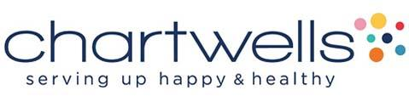
AOD School Food Program
Offer vs. Serve K8

August 30th
Lasagna Roll-Up
Carrot Sticks
Celery Sticks
Grapes

August 31st
Chicken Ranch Wrap
Cauliflower Florets
Broccoli Florets
Orange Wedges

September 1st
Turkey Nachos
Refried Beans
Sliced Cucumbers
Chilled Fruit

September 2nd
NO SCHOOL
Happy Labor Day!

Entrée 2 - Soy Butter & Grape Jelly
Entrée 3 – Garden Chicken Salad w/ Pita Bread

- School’s MUST offer all 5 components (Grain, Fruit, Milk, Protein and Veggie). Students MUST choose 3 or more food groups. 1 component MUST at least be ½ cup fruit and/or vegetable

