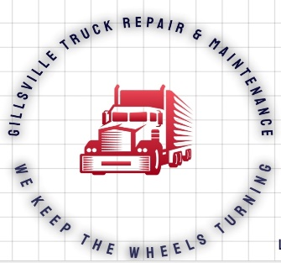
Gillsville Truck Repair & Maintenance LLC
4290 HOLLY SPRINGS RD
GILLSVILLE, GA 30543 706-318-2070

REQUEST FOR REPAIR ORDER

DATE: ____________ TIME: ________ RO# _________
CUSTOMER NAME: _____________________________
ADDRESS: ____________________________________
PHONE: _____________________ CONTACT NAME: _________________ EMAIL: _______________
MAKE: ________MODEL: _______________ YEAR: ______ COLOR: _________
VIN: ________________________ UNIT# ________ MILEAGE: ______________
COMPLAINT: ___________________________________________________________________________________________________________________________________________________________________________________________________________________________________________________________________________________________________________________________________________________________________________________________________________________________________________________________________________________________________________________________________________________________________________________________________________________

Customer Authorizes Gillsville Truck Repair & Maintenance LLC to perform service on vehicle and authorize service personnel to operate vehicle for testing purposes.
Gillsville Truck Repair & Maintenance LLC is not responsible for loss of articles left in vehicles caused by theft, fire, or any other event.
Customer or person executing this repair order on behalf of customer represents they are duly authorized by owner to consent service.
Customer understands diagnostic time is billed on time and material basis and is subject to 1 HR minimum labor charge.
Customer hereby agrees all service work is COD unless prior arrangements have been made, Gillsville Truck Repair & Maintenance LLC will retain possession of vehicle until invoice has been paid in full.

Authorized Signature: _____________________ _ Print Name: ________________________ Date: ________________

