Click on your Google icon on your computer, which looks like the icon below
 Once you click on the icon it will open up to the GOOGLE SCREEN below –
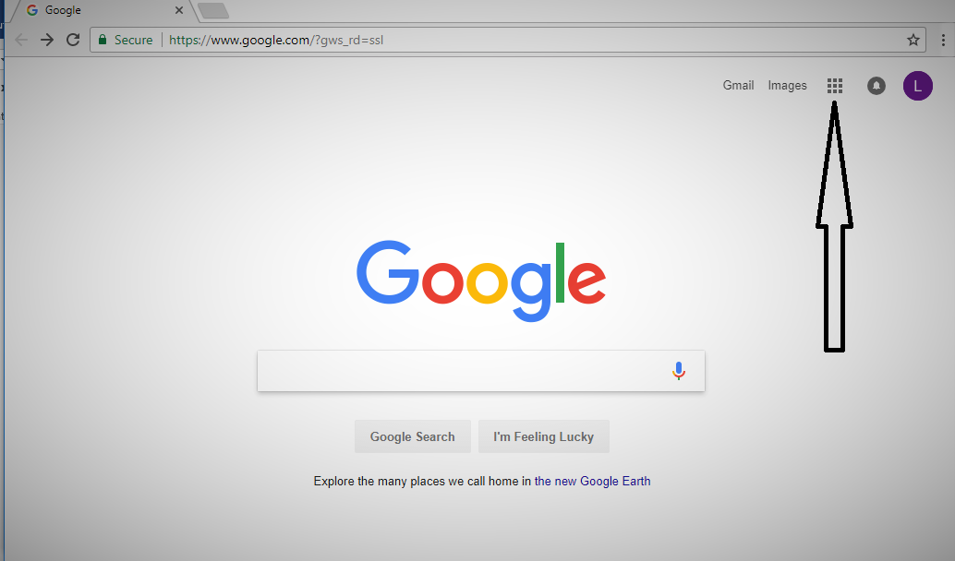
On the GOOGLE Screen shown above, select the dots which are formed into a square in order to access the Google Drive among all the Google Applications available. Once you click on the dots select the GOOGLE DRIVE ICON, which is shown below. This is where all the running ledgers are maintained. You will be invited to “View” the ledger that you are invited to. If you are a liaison and work with an Organization(s), that is what you will have access to see, if you work with Individuals/Families that is what you will have access to see. Here you find the various applications that work for Google. Select the “Drive” icon below.

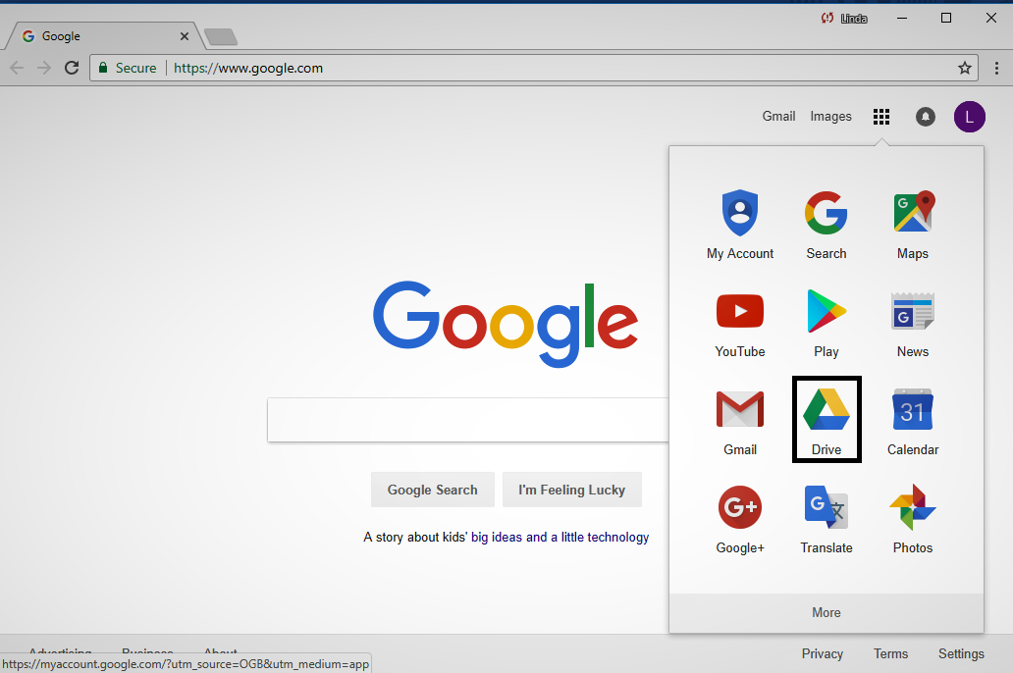
Once you select the Drive it will open to the Google Drive Screen. It will automatically open to “My Drive” if you have used Google Drive you may find a ledger you have worked on, if not click on “Shared with me” and it will be there. Your all set. That is how you would go to the ledger each time you visit it, unless you use it quite often. In that case you will find it automatically will move to “My Drive”. THE END
