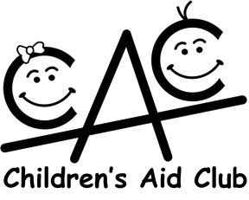
3296 N FEDERAL HIGHWAY #11503 FT. LAUDERDALE, FL 33339-1503

www.ChildrensAidClub.org

Application for Funding for In-Kind Gifts & Services

Date of Application_________________________

Name of Organization _________________________________________________________________________________________
Address_____________________________________________________________________________________________________
Phone number of organization ____________________________
Name and Title of Contact Person________________________________________________________________________________
Phone number of Contact Person______________________________ Extension_______________
Email address of Contact Person______________________________________________________

Purpose of request
Amount Requesting for 2019-20 _________________________________________________________________
Please be specific on what, how and when the In-Kind Gifts, funds & services will be spent ____________________________________________________________________________________________________________ ____________________________________________________________________________________________________________________________________________________________________________________________________________________________________________________________________________________________________________________________________
Number of Children served _____________________________________Ages __________________________________
Amount estimated per child _____________________________________________________________________________________
Other factors you wish to be considered regarding this request__________________________________________________________
____________________________________________________________________________________________________________
Please supply the following:
Non-Profit Status ________________________________________ Federal ID#____________________________________

Total annual budget_____________________________ What percentage of your budget is administrative costs? ________________

How many other locations and where? ____________________________________________________________________________

Please list the source(s) of your funds along with the amounts from each source:

Federal, State & County Assistance including grants__________________________________________________________________

Non-governmental commitments, gifts & grants _____________________________________________________________________

Special Events________________________________________________________________________________________________

Other Income revenue _________________________________________________________________________________________

___________________________________________________________________________________________________________

Signature and title of person completing this form___________________________________________________________________

If more space is needed, please attach extra pages as required. Please note the number of pages attached: ____________.

Please attach to this form the names of your Board of Directors along with your most recent Form 990 and Financial Report, if applicable, and return to Children’s Aid Club Member presenting this application OR email to the CAC Welfare Chairman, Linda Ianelli – lianelli@comcast.net
Revised 2017 16

