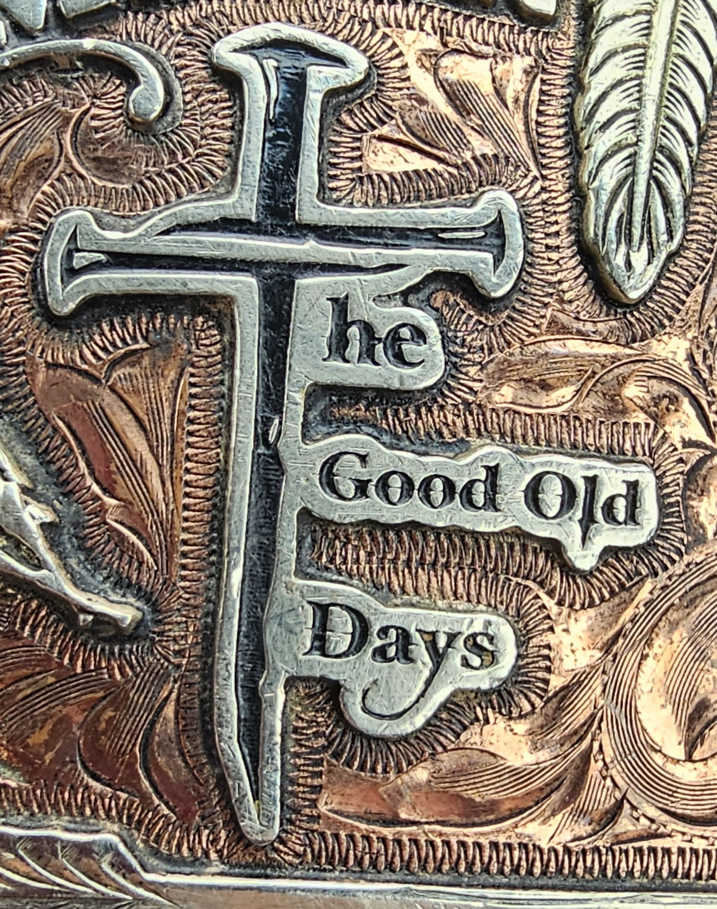

**Pending**

Expo Barrels - $5

*60 sec time limit - $5 pentaly for going over the time limit*

Open 4-D Barrels - $30

$200 added to Open

Open 4-D Splits .5, 1,2 second

Sidepots – Carry Over from Peewee and Open

Adult 3-D - $20 Splits - 1 second

Youth 3-D $15 Splits - 1 second

Open 3 -D Pole - $20 ($100 added)

$10 Procesing Fee Per Rider

80% Payback on Jackpot Classes, (PeeWee, Open, Sidepot)

**Expo’s will start @ 5 p.m. – Pee Wee will follow**

**April 30, May 28, June 25, Aug 27, Sept 24**

**Wednesday Night Speed Jackpot**

**Good Old Days LLC**

***The Lincoln County Fairgrounds, The Good Old Days LLC, and/or Tara Edwards, will not be held responsible for any accident, injuries, or theft to any exhibitor, horse, or pony. Judges’ decisions are final. NO REFUNDS. Call 314-568-6165 before you hall to obtain arena or show information.***

***Will also post on Facebook at Good Old Days LLC***