S

Lincoln County Fair Grounds Dates: April 25th, May 16th, August 1st, August 22nd, September 19th, October 3rd October 17th (Rain Date – TBD)
Classes: All Shows Start at 11 a.m.
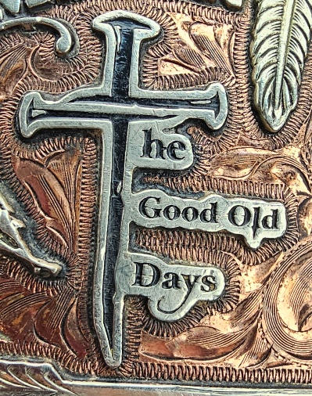
- Halter Classes- (Walk in and line up only)
  - Pony Model Halter

  - Mare Model Halter
  - Gelding Model Halter
  - Gaited Model
- Lead Line (6 and under)
- Walk-Trot Classes
  - Youth Walk Trot (12 Youth & under)
  - Jr. Walk Trot (13 Youth to 18)
  - Adult Walk Trot
- Western Pleasure
  - Western Pleasure Youth (12 Youth & under no stallions)
  - Western Pleasure Junior (13 to 18 & under no stallions)
  - Western Pleasure Adult
- OGB (Open GAITED Breed) Country Pleasure 2 Gait (walk and intermediate gait) – Eng. or West. Tack
- Ranch Walk - Trot
For Arena Conditions or More Information, Contact:
Tara Edwards
Ph 314-568-6165
Info@goodolddays.llc
  - Youth Ranch Walk Trot (12 Youth & under)
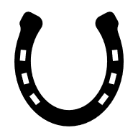
  - Junior Ranch Walk Trot (13 to 18)
  - Adult Ranch Walk Trot
- Ranch Riding
  - Youth Ranch Riding (12 Youth & under)
  - Junior Ranch Riding (13 to 18)
  - Adult Ranch Riding
- OGB Trail Pleasure 2 Gait (walk, intermediate gait, working walk)
Short Intermission
- Versatility
  - Youth Versatility (12 Youth & under)
  - Junior Versatility (13 to 18)
  - Adult Versatility
- 3–D Poles
Rules / Fees / Info:
- Negative Coggins Required
- $5 CASH ONLY Gate Fee Per Person.
- Entry Fees $8 per Class
- $5.00 Fee for CC Card
- Ribbons for Places 1-5
- Ponies 54” and Under
  - Youth 3-D Poles (12 Youth & under)
  - Junior 3-D Poles (13 to 18)
  - Adult 3-D Poles
- 4–D Barrels
  - Youth 4-D Barrels (12 Youth & under)
  - Junior 4-D Barrels (13 to 18)
  - Adult 4D Barrels

