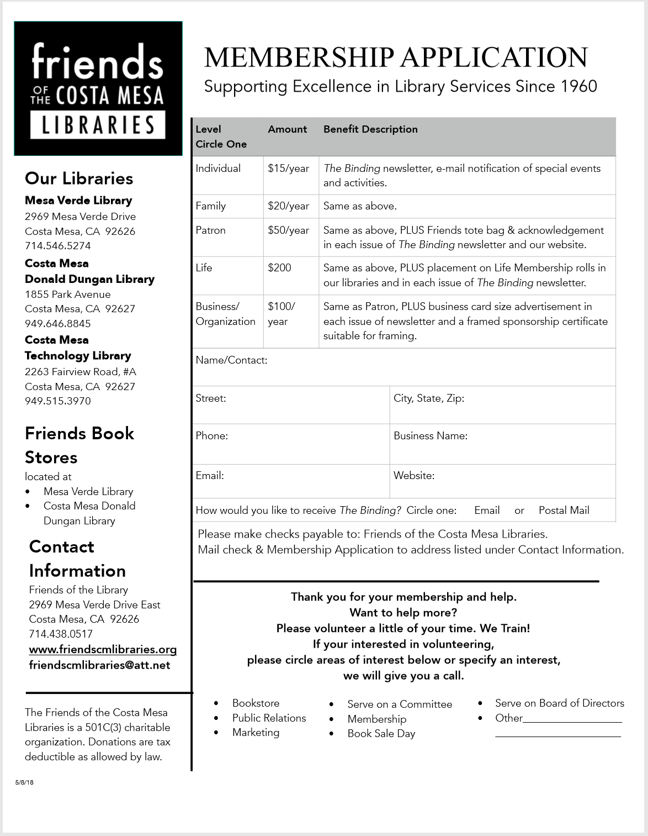

Sue Paskerian Eliabeth V Pattinson Melissa & Daniel Pietenpol Cynthia Reynolds Lene & Jim Righeimer John D. Rittenhouse Carolyn Russell Dianne Louise Russell Tehnaz & Richard Rutledge Babara & Dan Rycroft Tina & Ken Ryder

Terry Sanders

Arlene Schafer Laurie Schoner Marilyn & Terry Shaw Willa Sigler Margaret Smith Gene Stanley Donna & Dean Stapleton Paula & Jude Sturman Katherine & James Tamburro Trinh-ai & Robert Tasedan Barbara Thibault Carolyn Thomas Pauline Thomas Aniz Uhler Laurie & Larry Weichman Jane & Forrest Werner Kathleen West Ann & Don Williams Joyce Woerner

Alison Wright

Van O. Wright Kathie & Ray Young

Judy & Norman Ablett John D. Adams, Jr. Susan & Richio Aikawa Charlotte & Richard Alexander Laura Anderson & Ted Schulman Toby & Peter Baran Kathy & Jess Bequette Carolyn Bjork Darcy & Ross Bolton Millie & Myron Bonca Dale Braun Wendy Bryan A.A. & Audrey Burnand Chris Cameron & Bill Butler Stephanie Campbell LuAnn & Rick Campo Ken Cave Victoria Chau Laetitia & Harvey Chernik Tracey & Hugh Daschbach Barbara Davia Victoria Davis Marian & Pete Dickey Joan M. Donahue Susan Baer Epstein Patricia Evans Lois & James Fisher Kathryn & James Fitzpatrick Marilyn M. Fry Joanne C. Gant Sydney & Larry Gielow

Mary Ellen & Art Goddard Tamar & Dan Goldmann Elizabeth Grant Anne Hinkle Cheryl Hosman Ruby Hunt Debby & Terry Koken Sue & Kurth Krause Judith & Andy Lamb Barbara & Mark Les Gina Lesley Susan Lester Rachel Levin Nora M. Lusk Lois Machida Setsuko Malora Janette Manderson Carolyn Marsh Jeﬀ Mathews Audrey McLaughlin Linda Mitchell Robert Mohr Barbara & Steve Morihiro Brion Munsey Joan Murphine Crystal Nay Sherrie & Darrell Neft James M. Neighbors Dolores N. Nevins Minh Nguyen Thuc X. Nguyen Cheryl & Bob Ooten

**Friends of the Costa Mesa Libraries - Life Members**

Louisa Arnold & Glen Davidson

Karen & Joe Barloon

Carol Bernstein

Chloe & Edward Conti

Megan Delaney

Carol Halbach

Lane & Linda Koluvek

**2019 Patrons**

Tina Reinemann & Denise Palaferri

Arlis Reynolds Nora Sharp

Sam & CinWatson

Susan & Michael McGuire

Lee McCullough

Joe Merkel

Sandra & Joe Moyer Ursula G. Oien

Janice Marie Coxon Orr Deborah & David Rector