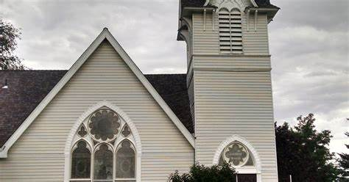

Church Wedding Information Date of Wedding _________________

Time of Wedding ___________________ Arrival Time _____________

Date of Rehearsal _____________ Time of Rehearsal ____________

Arrival Time ____________________ Decoration Time Needed: YES / NO Decoration Time __________________________

Name of Contact Person _________________________

Email Address _________________________________ Telephone_____________ Cell _________________ Other Phone_____________________

**\*\* We do not hold receptions on-site. \*\***

Bride Full Legal Name ______________________________________

Groom Full Legal Name_____________________________________

Address:______________________________

Address ___________________________________

City ___________________St_____Zip_______

City ___________________St_____Zip__________

Email Address:___________________________

Email Address:______________________________

Telephone: ______________________________

Telephone: ______________________________

Cell Phone ______________________________

Cell Phone ____________________________

PASTOR Performing Christian Ceremony Name __________________________ Church ___________________________ Address ___________________________ City______________ State ____ Zip ______________

Email Address _____________________________________

Telephone ____________________

CEREMONY DETAILS

Music (iPod,CD,etc.)______________________________________________

Type of Decorations______________________________________________________

Number of Guests (100 MAX)___________ Wedding Party Bridesmaids Groomsmen 1._____________________________________

1. _________________________________

2. _____________________________________

2. _________________________________ 3._____________________________________ 3.__________________________________ 4._____________________________________ 4.__________________________________ 5._____________________________________ 5.__________________________________

Flower Girl Ring Bearer

1._____________________________________ 1.__________________________________ 2._____________________________________ 2.__________________________________

Wedding Fees A property host is required to be on site at all times. Church Fee $600.00 Non-refundable Deposit $300.00 to reserve your date Additional Fee Per Hour $150.00/hr. Balance due 45 days prior to the ceremony. Payments not received by due date are subject to cancellation. Final Payment Due: ___________________________________ Venue Host:_______________________ Contact Number: _________________________ For office use only Deposit Date Received _______Final Payment Due_________________ Wedding License #_______________ Date_______________ County______________ All Fees Disbursed __________________ Wedding Report ________________ Wedding Cancelled by ____________________ Date_________Any Refund_____________