
Tatiana’s Ukulele Chord Chart
Baritone
Major Chord | Minor Chord | 7th Chord | Often Used | Sometimes Used | Rarely used/  substitutions
A  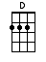 | Am  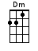 | A7 (alt)  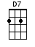 | A7  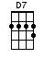
B  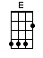 | Bm  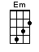 | B7  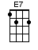 | Bm7  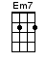 | Bb  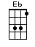
C  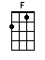 | Cm  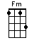 | C7  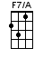 | C#7  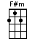 | C/G  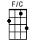
D  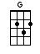 | Dm  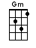 | D7  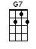 | D6  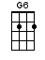 | Dsus4  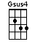 | DM7  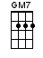
E  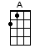 | Em  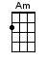 | E7  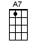 | Em7  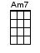
F  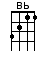 | Fm  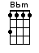 | F7  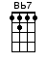 |  |  | (F substitute)  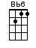
G  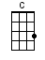 | Gm  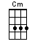 | G7  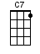 | G6  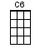 | Gm7  