
Tatiana’s Ukulele Chord Chart
Major Chord | Minor Chord | 7th Chord | Often Used | Sometimes Used | Rarely used/  substitutions
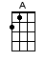 | 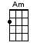 | 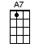 | 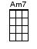 |  | 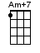
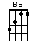 | 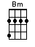 | 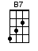 | 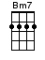 | 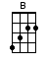 | 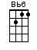  (can be used as Bb)
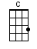 | 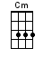 | 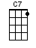 | 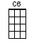 | 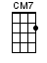  “Christmas Chord” | 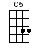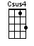
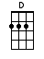 | 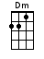  “squished F” | 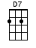 | 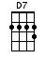 |  | 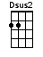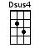
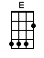 | 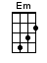  “stairsteps” | 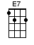 | 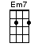 | 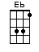
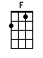 | 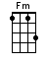 | 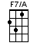 | 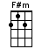 | 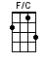
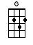 | 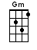 | 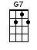 | 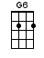 | 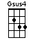 | 