Nordstrom Beauty Intake Form
A brand is to fill out the below form in its entirety. If and when something may not apply, please put an N/A. Providing as much detail upfront will speed up our planning process.

EVENT OVERVIEW

Brand: Clarins

Event: Holiday Glam Events

Event Format: Elevated Skin Solutions Events- location at counter or off floor in Spa Room.

GWP Information: (insert details)
- GWP Description: Mary’s Meals GWP 10/28-11/10
- GWP Qualifier: $75 Clarins Purchase
- GWP Value: $107.36- $240.30 (Precious GWP w/ $200 Precious Purchase).
- GWP Image (please provide a dropbox or westransfer link)

Focus Items (provide vpn, description, and upc or these will not be supported with a lift):

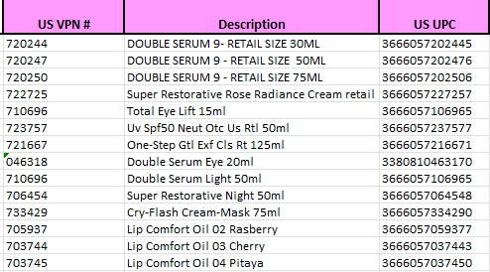

Daily Deals / Promos (Provide any and all daily deal promotions tied into an event to avoid crossover with other pre-existing deals.)
- 11/21-12/3 Cyber- 30% off Body SKUs
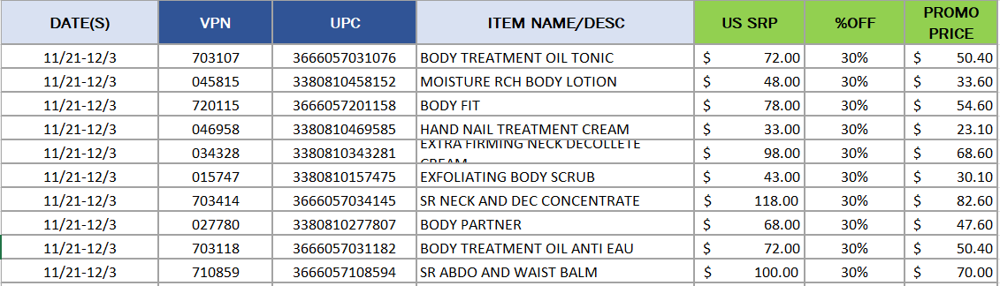

PROMOTIONAL ELEMENTS / EVENT TOOLS

Event Copy / Description: Elevated Skin Solutions Events- a re-energizing treat to give your skin a beautiful glow featuring our newly reformulated best seller Double Serum with the power to change your skin's future. We'll select the perfect routine for you, then apply a touch of makeup (Lip Oils, SOS Primers)- so you're ready for the day.

Event Image (please provide a dropbox or westransfer link):

EVENT SET-UP, ELEMENTS & BUDGET

EVENT SET-UP REQUEST (Provide any preliminary details or guidelines on how you would like the event set-up. (30 white chairs to be set up theater style facing the host. 6 store owned tables to be set-up in U-Shape)

EVENT ELEMENTS:

ELEMENT: | Event Level Considerations | ELEMENT DESCRIPTION: | ESTIMATED COST (all costs are estimates and subject to change based on time of year and or market) | BRAND REQUEST WITH DESIGRED BUDGET BY DOOR PER ELEMENT
Signage | L1 – L3
Chairs and Tables (Store Owned) | L1 - L2 | Nordstrom has the following items to offer for $0 cost  • 6ft folding tables with linen (black, grey or white)  • Black folding chairs  • Directors Chairs  • Artistry Tables | $0
Rentals | L1 - L2 | ex. Highboy tables, chiavari chairs, host table, linens, etc.. Include color scheme. (All black, all white, gold chair & white linen, etc.) Please note NYC does not use rentals with linen. | Varies based on request and market
Catering | Café Catering | L2-L3  Caterer | L1-L2 | Catering can be supported by Nordstrom Café / Ebar and or by an outside local caterer based on timelines, budget and brand request.  • Catering request via the Café  o Note that the offering of food and beverage will be a bit more basic via our Café or Ebar.  o Please budget no less then $25 per head  o Alcohol is not to be served by our Café during store hours outside of their restaurant  • Catering request via Local Caterer  o Note, a brand can be more specific on their catering request  o Alcohol is allowed to be requested  o Please budget no less then $65 per head. Price per head will vary by market.  o Note, our Nordstrom Utah locations do not serve alcohol. | Catering can be supported by Nordstrom Café / Ebar  o Please budget no less then $25 per head  Catering request via Local Caterer  o Please budget no less then $65 per head. Price per head will vary by market.
Kendu Backdrop | L1-L2 | 9x9ft branded or co-branded backdrop. Brand to send 350 dpi resolution image with font package to Event Lead. Backdrop has 8 week lead time. ***Nordstrom branded backdrop is available if there is no budget for branded kendu backdrop. Please enter "Nordstrom kendu" if preferred. | $350 per location
Floral | L1 -L3 | Provide exact floral guidelines and floral amounts | Small arrangement $75, Medium arrangement $100, Large arrangment $150+
DJ | L1 -L3 |  | 3 Hours | $575  4 Hours | $635  5 Hours | $685  6 Hours | $725  7 Hours | $755  Branded DJ Booth (L1-L2) | $250
Engraver, Bottle Painter, Etc. | L1 -L3
Other | L1 -L3

EVENT STORES & DETAILS

STORE NAME | STORE NUMBER | EVENT DATE | EVENT TIME | ATTENDACE GOAL | VOLUMN GOAL | SUPPORTING BRAND NAME/ TITLE / CONTACT | Indicate all Event Elements (catering, floral, both, etc.)
Downtown Seattle | 1 | 11/16 | 10-6 | 20 | $8,000 | Mizuho.Sutton@clarins.com | DS9 Master Class, Catering, Floral
Bellevue | 4 | 11/2 |  |  |  | Mizuho Sutton | Street Team Event
Southcenter | 5
Tacoma Mall | 6
Spokane | 9
Alderwood | 10
Downtown Portland | 20
Washington Square | 25
Murray | 32
Park Meadows | 34
Cherry Creek | 37
City Creek Center | 73
Manhattan Tower | 210 | 11/2, 11/23 |  | 64, 24 | $8.0, $3.0 | Agnes Pawlowski
Michigan Avenue | 220 | 11/1 | 11-6 | 24 | $3.0 | Tina Kotsionis | Precious Masterclass
Oakbrook | 221 | 11/13, 11/20 |  | 24, 24 | $3.0, $3.0 | Narta Jonuzi
Mall of America | 222
Old Orchard | 223
Woodfield Mall | 225 | 11/9,11/16 | 11-6 | 24,24 | $3.0,$3.0 | Tina Kotsionis | Spa Event
Beachwood Place | 227
Somerset North | 228
Oak Park Mall | 230
West County | 232
Easton Town Center | 234
Twelve Oaks | 235
Ross Park | 237
Keystone | 238
Kenwood Towne Centre | 239
Saint Louis Galleria | 240
Mayfair | 282
Ridgedale Center | 283
South Coast Plaza | 320 | 11/10 |  | 24 | $3.0 | Adela Ramirez
Brea Mall | 321 | 11/16 |  | 24 | $3.0 | Adela Ramirez
Los Cerritos | 322 | 11/15 |  | 24 | $3.0 | Yesenia Hernandez | Spa Event
Mission Viejo | 326
Irvine Spectrum | 330
Fashion Island | 333
Americana | 340
Topanga Plaza | 341
Del Amo Fashion Center | 342 | 11/16 |  |  | $3.0 | Yesenia Hernandez | Spa Event
Santa Anita | 345
The Oaks | 348
The Grove | 349
Santa Monica Place | 353
Fashion Valley | 360 | 11/15 |  | 24 | $3.0 | Adela Ramirez
University Town Center | 361 | 11/16 |  | 24 | $3.0 | Adela Ramirez
Fashion Square | 380 | 11/2/24 | 11:00am | 10 | $3,000 | Stacey LiBrandi 480-236-0494 | Spa
Century City | 384
Fashion Show | 386
Hillsdale Mall | 420
Walnut Creek | 421
Palo Alto | 422
Corte Madera | 423
Valley Fair | 425 | 11/16 |  | 24 | $3.0 | Annabel Ramirez
Galleria at Roseville | 434
Garden State Plaza | 520 | 11/16 |  | 24 | $3.0 | Agnes Pawlowski
Menlo Park | 521
The Westchester | 523
Roosevelt Field | 524
Westfarms | 526 | 11/9 | 12-5 | $1.0 | 8 | Sasha
Short Hills | 527 | 11/23 |  | $2.5 | 20 | Agnes Pawlowski
Natick | 531 | 11/9 | 12-5 | $1.2 | 10 | Bonnie Tichnor
South Shore Plaza | 534 | 11/9 | 12-5 | $1.2 | 10 | Maria Lima
Burlington | 535 | 11/9 | 12-5 | $1.0 | 8 | Alexa Papous
Northshore | 536 | 11/9 | 12-5 | $1.0 | 8 | Kaira Martinez
Norwalk | 538
Tysons Corner | 600
Pentagon City | 621
Towson Town Center | 622
Montgomery | 623
King of Prussia | 629
Columbia | 631
Cherry Hill | 637
Christiana | 639
Ala Moana | 706 | 11/16.24 | 11:00am | 25 | $5,000 | Stacey LiBrandi | Precious Masterclass
The Dallas Galleria | 720
Northpark | 723
Stonebriar Mall | 724
Houston Galleria | 730
Barton Creek Square Mall | 731
LA Cantera | 732
Domain Northside | 733
Woodlands Mall | 746
Southpark | 750
Streets at Southpoint | 751
Green Hills | 759
Perimeter Mall | 760
Boca Raton Town Center | 762
Shops at Merrick Park | 763
International Plaza | 765
Phipps Plaza | 772
Palm Beach Gardens | 773
Aventura | 774
St. Johns Town Center | 789

NORDSTROM EVENT PARAMETERS

LEVEL 1
Lead Time: | 10- 12week (Lead time is not considered complete until all assets and format at inputted into WF)
Minimum Volume Goal: | $35k+
Budget: | $15-$20K to be re-evaluated based off of requested elements
Event Formats to consider: | Personal Appearances with high profile celebrity, pop-ups, panel with high-profile talent/s, Beauty Trend Event, etc.
Event Elements to consider: [Note, while all elements below can be considered, not all elements together would necessarily fit within budget.] | o Hired caterer  o Rentals  o Hired AV  o Hired customization  o Hired DJ  o Branded kendu backdrop (with Corp VM approval)  o Branded DJ booth graphic (with Corp VM approval)  o Floral/s inclusive of floral giveaway, floral photo wall, etc. (with Corp VM approval)  o Floral/s inclusive of floral giveaway, floral photo wall, etc. (with Corp VM approval)  o Viewing parties**  **Doors subject to review for approval and each door must be able to contribute min of 10k min for consideration to host this format.
LEVEL 2A
Lead Time: | 8 week (Lead time is not considered complete until we have all assets and format in WF)
Minimum Volume Goal: | $25k
Budget: | $5k - $7k
Event Formats to consider: | Masterclasses with higher profile talent, National Artistry Events, etc.
Event Elements to consider: [Note, while all elements below can be considered, not all elements together would necessarily fit within budget.] | o Hired caterer  o Rentals  o Hired AV  o Hired customization  o Hired DJ  o Branded kendu backdrop (with Corp VM approval)  o Branded DJ booth graphic (with Corp VM approval)  o Floral/s inclusive of floral giveaway and or floral arrangements, etc.
LEVEL 2B
Lead Time: | 6 - 8 weeks (Lead time is not considered complete until we have all assets and format in WF)
Minimum Volume Goal: | $10k
Budget: | $5k
Event Formats to consider: | Masterclasses, Artistry Events, etc
Event Elements to consider: [Note, while all elements below can be considered, not all elements together would necessarily fit within budget.] | o Café catering request (no alcohol) and or potential for local caterer to support  o Rentals  o Hired customization  o Hired DJ  o Floral arrangements  o Store owned kendu backdrop (with Corp VM approval)
LEVEL 3
Lead Time: | 4 weeks
Minimum Volume Goal: | $10k & Less
Budget: | $5k & Less
Event Formats to consider: | At counter artistry, gift with purchase, etc.
Event Elements to consider: [Note, while all elements below can be considered, not all elements together would necessarily fit within budget.] | o Floral  o Store owned chairs and tables  o Minimal activations (DJ, Engraver, Bottle Painter)

