

April 18, 2024

Hello Sales and Education Executives,
We understand your concerns about the difficulties searching for products in Elite.
Therefore, we created a Products Master List for reference. The list contains testers, disposables, and visual merchandising items that are active in the system. A “Custom Description Name” is included to provide you with a reliable way to identify and locate the product’s sku information. There are other details such as item’s group, category, line range etc that you can filter by as well.
You can enter item number, French number, EAN or Item description in the search function when you want to add product to a your basic or VM order. Below is an example of search result for Super Restorative Anti-Aging Abdomen and Waist Body Cream:
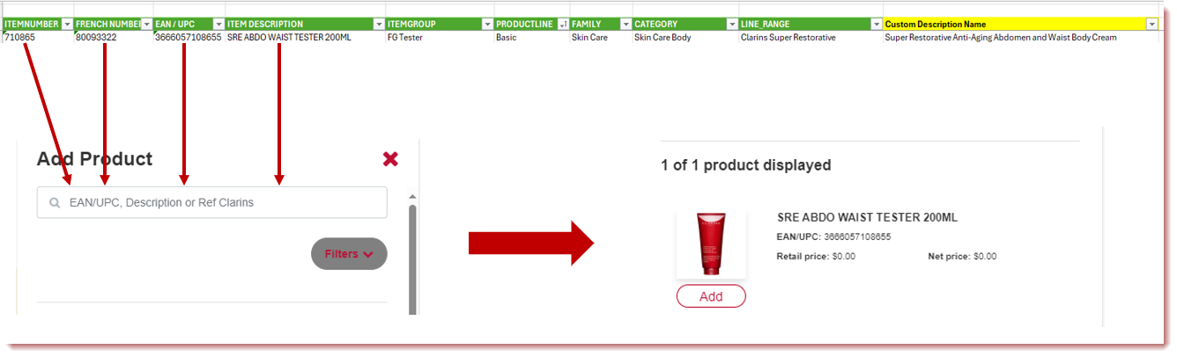

Please note new launch testers are added to the ordering module one month after the launch ship date unless noted otherwise.
The Products Master List is posted in Reference Tools (the filename is CLA Elite - Business Product Master List) and updated periodically.

Please reach out to any of us on the team with questions!!

