

May 13, 2024

Hello Sales and Education Executives,
The Merchandising team is happy to release our first Tasks on Clarins Elite!

As a reminder, you will be able to see all Tasks you have yet to complete on your Home Screen in the Activities section (shown below for reference):
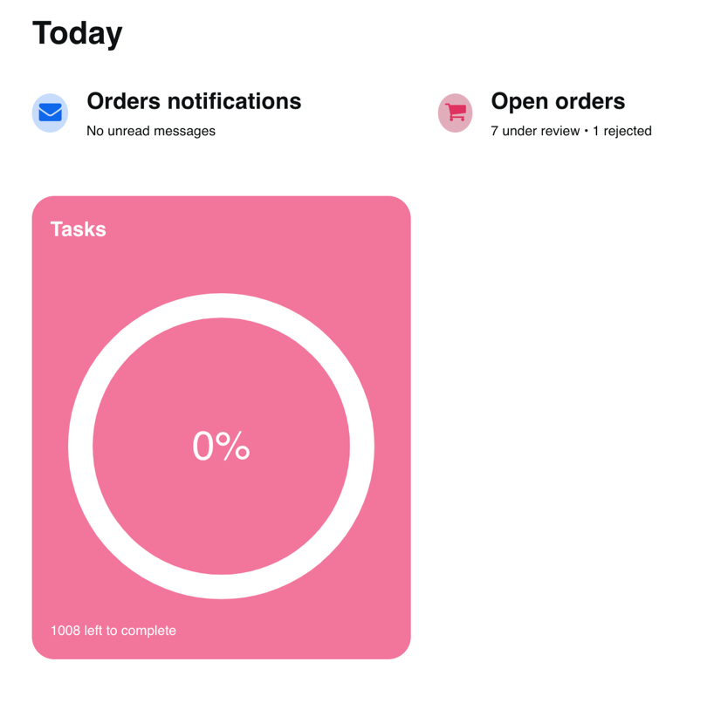

You can also find Tasks by store by checking the Store’s Profile Page and selecting the Tasks section.

Please reach out to Lisa Rizzo with any questions!

