

August 26, 2024
Hello Sales and Education Executives,
Hope the in store execution of Double Serum Generation 9 is going well so far!

Please be advised that all Merchandising Guidelines have been posted on Elite for your review.
As a reminder, all guidelines can be found on the Store Profile Page in the Visual Guides and Planograms Section. You will be able to see the Guideline for the specific store you are viewing.
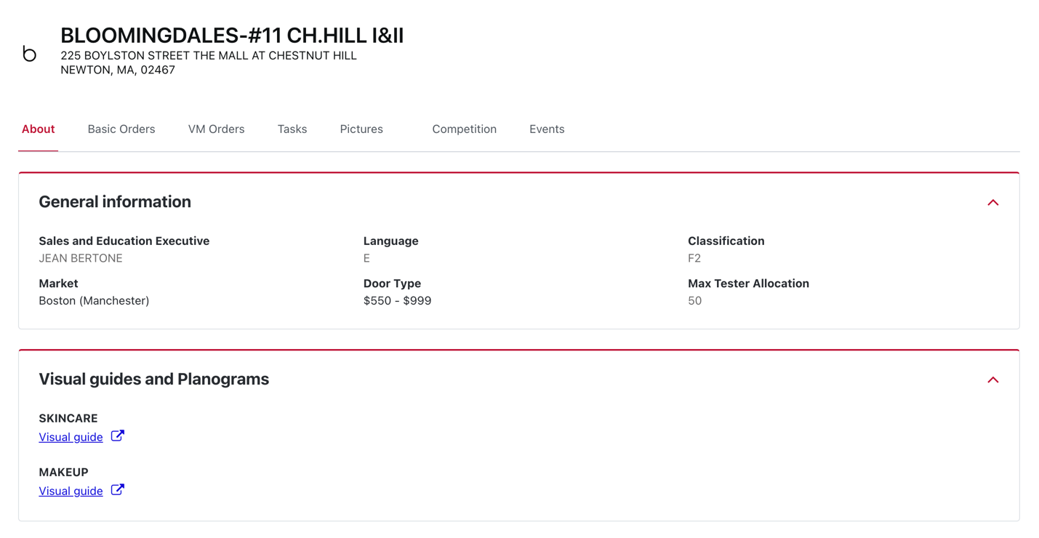

We also posted a Task for Double Serum Generation 9 to see all your beautiful launch photos!
As a reminder, you will be able to see all Tasks you have yet to complete on your Home Screen in the Activities section (shown below for reference):
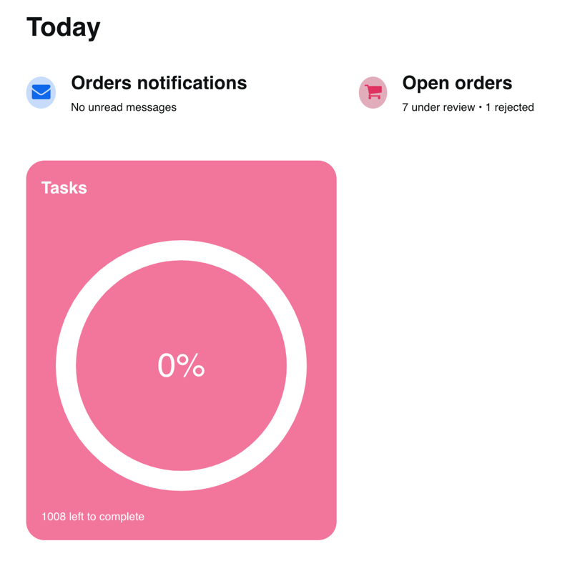

You can also find Tasks by store by checking the Store’s Profile Page and selecting the Tasks section.

Please reach out to Lisa Rizzo with any questions!

