

ACCESS AND VISIBILITY
In order to more efficiently track, manage, and address user issues within the Elite application, please submit a Help Desk ticket, as follows:
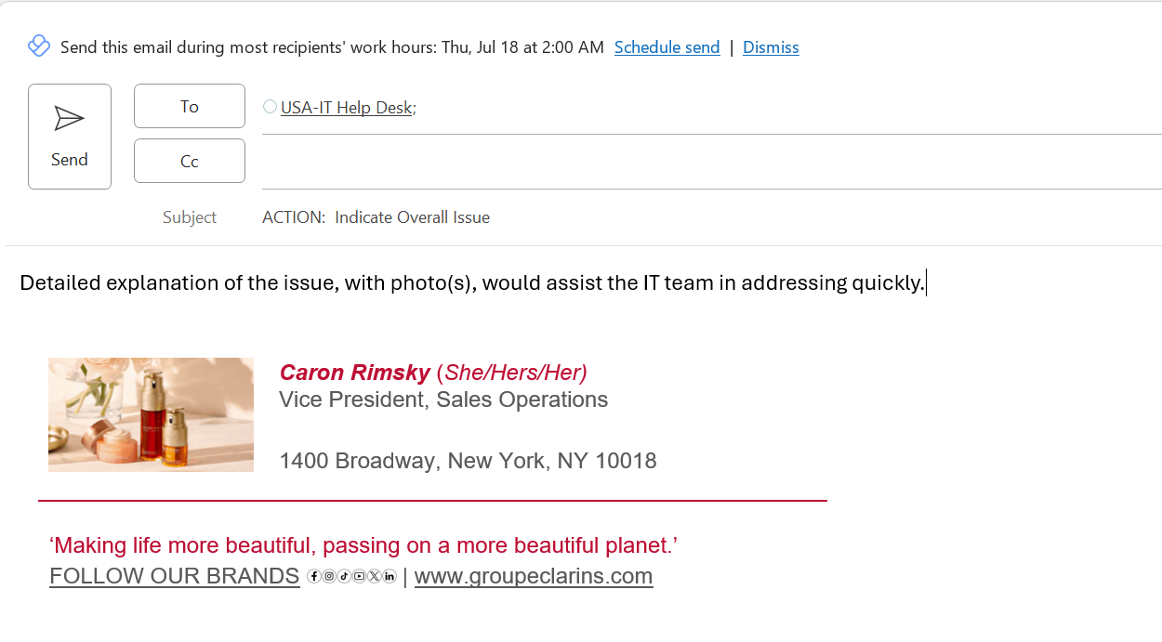

While contacting an individual directly may seem like an easier and faster way to get the answer you are seeking, it can create bottlenecks for IT and delay the response.

Thanks so much for your support.

