

ELITE MOBILE ACCESS
We are aware that some of you have experienced Elite mobile access challenges and are working to find a permanent solution.
In the interim, if you are denied access via mobile, please follow the following instructions, which should correct the issue.
- Please access the Elite application on your laptop: Clarins Elite (cgapps.net)
- You may need to log-in. If so, please follow the instructions below:

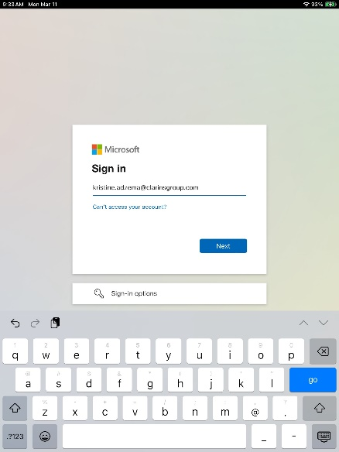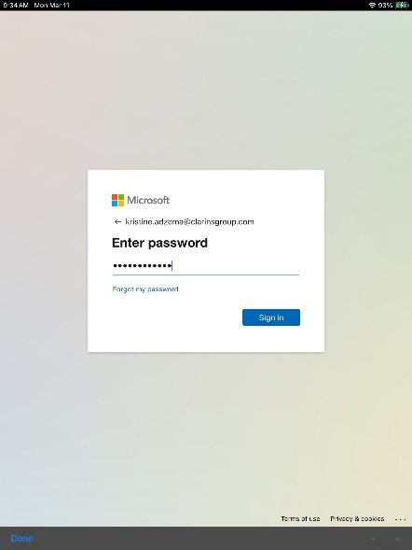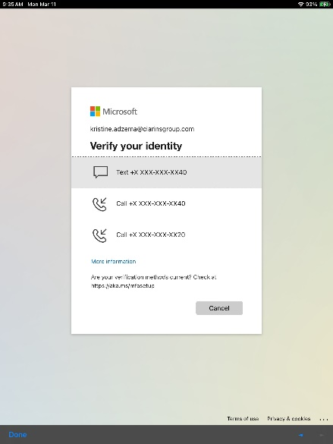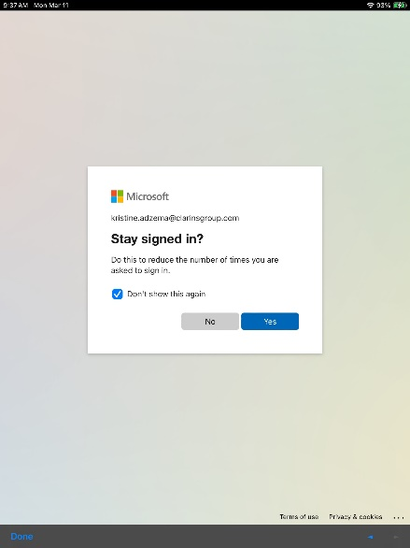

- Once you have successfully logged into Elite on your laptop, please go back to the mobile application and try logging in. You should have been able to re-establish the connection.

