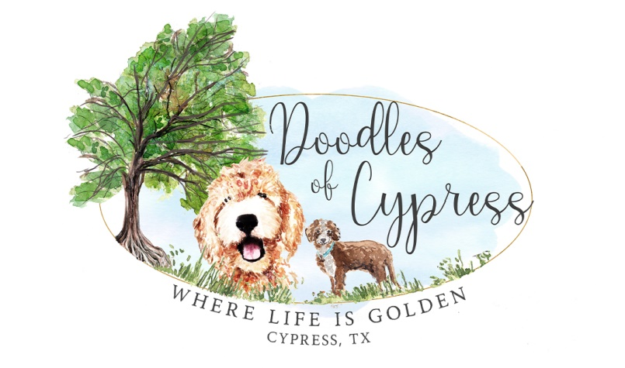

Doodles of Cypress – Contract for Use of Stud

*Jennifer & Charlie Nichols ~ Nichols’ Lucky Tucker DOC*

**Stud Dog Information:**

Registered name: Nichols’ Lucky Tucker DOC

GANA Registration #: 34884

Call Name: Tucker

Sire: Sir Linus (Donna’s Doodlebugs); Red & White Parti

Dam: Evie Patootie (Donna’s Doodlebugs); Red

Owner Name (at time of mating): Jennifer & Charlie Nichols

Address: 12614 Manorwood Lane, Cypress, TX 77429

Phone: (DO NOT SHARE WITH PUBLIC!!!) 832-330-5758

Email: info@DoodlesOfCypress.com

**Dam Information:**

Registered name:

Registration #:

Call Name:

Sire:

Dam:

*(Dam Information, Continued from page 1):*

Owner Name (at time of mating):

Address:

Phone:

Email:

**This contract is entered into by Stud Dog Owner, Jennifer & Charlie Nichols, hereafter referred to as “Stud Owners,” and Dam Owner(s), __________________________________, hereafter referred to as “Dam Owner(s).”**

This Stud Contract will guarantee the mating of Nichols’ Lucky Tucker DOC, hereafter referred to as “The Stud,” which has been previously described under “Stud Dog Information,” above AND the Dam, _______________________, previously described under “Dam Information” above. The Dam Owner(s) and Stud Owners certify that the information provided herein is true and correct, and that each named dog is free from fleas, ticks, worms, any sexually transmitted diseases, and that all vaccinations are up to date.

If LIVE COVER is used, Dam Owner(s) must provide have a negative Brucellosis test prior to mating.

The Dam Owner(s) and Stud Owners agree to disclose copies of the (1) Dam’s and Stud’s registration certificates, (2) most recent vaccinations, (3) current rabies certificate, (4) Microchipping number, (5) current pictures of the animal, (6) copies of ALL GENETIC & OFA/PENNHIP Testing. The Following Are Required for breeding: Genetic Panel (i.e. Embark, Paw Print, Animal Genetics, etc. – NOT WISDOM), OFA Hips of GOOD or EXCELLENT (or PennHip passing score), OFA NORMAL: eyes, elbows, patellar, basic cardiac. (7) a copy of a valid Driver’s License, and certify that the information provided is true and correct. All of these are required for the Dam Owner(s) to produce, unless otherwise specified by Stud Owners.

**STUD FEE**

***To be paid up front before Breeding***

Tucker’s servicing fee is $2000.00. This does NOT include collection or shipping.

**DEFINITION OF “LITTER”**

A Litter, for the purposes of this Contract, is defined as a **minimum of 2 puppies born alive**. If Breeding does not take or results in only 1 live puppy, the Dam Owner(s) will be owed one (1) additional breeding free of charge (not including collection and shipping fees). Once that additional breeding has taken place, this contract is considered fully satisfied and Stud Owner owes nothing more to the dam owner.

**STUD DOG OWNER AGREES TO:**

1) Provide documentation of current vaccinations and Rabies vaccination

2) Take proper care of the Dam while in Stud Dog Owner’s charge (if dam boards with live cover)

**DAM OWNER AGREES TO:**

1) Pay the agreed Stud Service Fee before the Dam is serviced – Fee will need to be paid via Zelle to [JenniferNicholsLPC@gmail.com](mailto:JenniferNicholsLPC@gmail.com) BEFORE The Stud leaves the house for collection OR The Dam arrives for servicing (if live cover);

2) Provide a four-generation pedigree of the Dam to be bred, if available;

3) Send the Dam in good health, free of fleas, ticks, parasites or infections, and in season;

4) **Send Stud Owners the tracked progesterone levels along with the type of progesterone machine used. Please note, Stud Owners will not do ANYTHING unless proper progesterone testing has been done, and the numbers indicate that proper timing is at hand. If Dam Owner(s) does NOT follow this instruction, The Dam Owner(s) forfeits the following: additional make-up breeding if litter does not take;**

5) Provide documentation of current vaccinations and Rabies vaccination;

**6) Provide proof of pregnancy ultrasound performed on The Dam no later than day 35;**

7) Notify Stud Dog Owner in writing, no later than 70 days after Breeding, if no pregnancy

results from the mating. Failure to do so will result in no repeat breeding at no charge;

8) Keep the Dam properly confined following Breeding to ensure no other Dog could mate

her accidentally before her season is complete;

9) Agrees to not knowingly sell or transfer puppies resulting from this Breeding to any

person or firm connected with the business of resale or wholesale of dogs;

10) Agrees NOT to sell any puppy resulting from this litter with BREEDING RIGHTS. All puppies sold from the resulting litter are sold on a **strict spay/neuter contracts;**

11) Agrees that if Dam Owner Program holds back a puppy or puppies from this breeding, that NONE of those held back will later be sold with Breeding Rights, but will be spayed or neutered PRIOR to leaving the Dam Owner’s custody. The Stud Owners prefer puppies be sold on a contract that stipulates spaying and/or neutering at 12 months and not before, however, The Stud Owners allow Dam Owner(s) to determine in their own contracts if they allow buyers to spay and/or neuter before 12 months of age, but ALL puppies sold are to be sold on a strict spay/neuter contract;

12) Pay ***any and all*** veterinary and financial arrangements, including, but not limited to:

* Collection Fee(s)
* Shipping Fee(s)
* Traveling expenses
* Emergency Vet Care related to this breeding
* ETC

**OTHER AGREEMENTS:**

**FOR LIVE COVER:**

Dam Owner(s) is responsible for providing proof of progesterone levels and all other testing done to the dam prior to and during Breeding to assure the proper timing of said Breeding. If Stud Dog is able to perform naturally and for some reason the Dam Owner(s) asks for artificial insemination or the Dam cannot be bred naturally, Dam Owner(s) is responsible for cost of said process. Dam Owner(s) is responsible for the cost of Dam’s food, supplements and medication while in the care of the Stud Owners.

Dam will be treated like one of the Stud Dog Owner’s own animals when in the care of the Stud

Dog Owner. Dam will be kept inside in Stud Dog Owner’s home during her stay. She will be

exercised, played with and pampered. Stud Dog Owner will make his/her greatest effort to make

sure this Dam will feel comfortable during her stay, as well as being adequately separated from

Stud Dog Owner’s other male dogs.

Dam will be bred two to three times naturally. We will make every effort to cover the entire breeding cycle of the dam.

No puppies resulting from the breeding may be sold to brokers, pet shops or puppy mills, or with breeding rights. Should this part of the contract be ignored Stud Dog Owner will pursue this clause in a court of law.

**Additional:**

Stud Dog Owner wishes Dam Owner(s) to understand that he/she takes the breeding of said

Stud Dog very seriously and will be very interested in the puppies resulting from this litter for

their entire lifetime.

The Stud Owner is not liable for any advice given or solicited from the Stud Owners to the Dam Owner(s) regarding the puppy’s health, birthing, raising of the puppies, etc. Any advice is to be considered opinionated guidance from the Stud Owner’s past experience of raising puppies/stud services.

By this Contract, it is specifically agreed, that the Stud Owners are not obligated to sign the

application for Litter Registration until, and unless, the Stud Fee and any other related financial

arrangements have been paid in full.

I understand the above written Contract and agree to abide by all sections both typed and written.

Both parties agree to all of the above agreements and terms.

_______________________________________________________

Dam Owner

_______________________

Date

_______________________________________________________

Stud Dog Owner

_______________________

Date