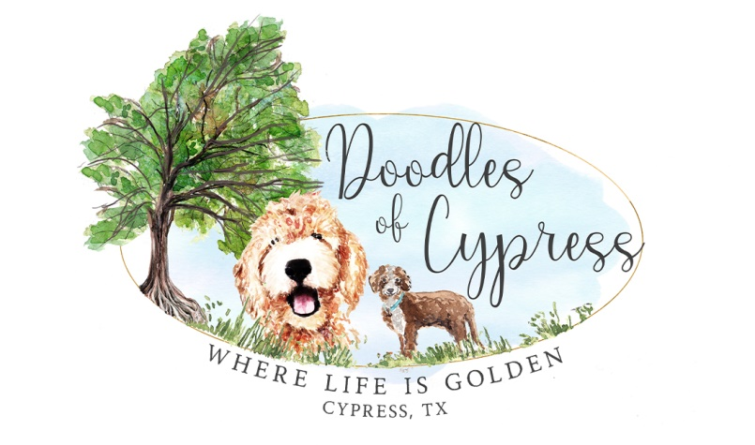
Doodles of Cypress – Contract for Use of Stud
Jennifer & Charlie Nichols ~ Nichols’ Dutch Boy Party of Five

Stud Dog Information:
Registered name: Nichols’ Dutch Boy Party of Five
Registration #: PR21558008
Call Name: Dutch
Sire: Wekay’s Desert Oasis, PR18084302 (Brown & White Parti)
Dam: Golly Miss Molly VIII, PR19676603 (White & Silver Parti)
Owner Name (at time of mating): Jennifer & Charlie Nichols
Address:
Phone:
Email: info@DoodlesOfCypress.com

Dam Information:
Registered name:
Registration #:
Call Name:
Sire:
Dam:
(Dam Information, Continued from page 1):
Owner Name (at time of mating):
Address:
Phone:
Email:
This contract is entered into by Stud Dog Owner, Jennifer & Charlie Nichols, and [Dam Owner
Name].
This Stud Contract will guarantee the mating of the previously described dog. The Dam Owner(s) and Stud Owners certify that the information provided herein is true and correct, and that each named dog is free from fleas, ticks, worms, any sexually transmitted diseases, and that all vaccinations are up to date.
The Dam Owners and Stud Owners agree to disclose copies of the (1) Dam’s and Stud’s registration certificates, (2) most recent vaccinations, (3) current rabies certificate, (4) Microchipping number if desired, (5) 4-generation pedigree, and (6) current pictures of the animal, (7) a copy of a valid Driver’s License, and certify that the information provided is true and correct.
STUD FEE
( ) To be paid up front before Breeding
( ) Paid as a Deposit, with Balance to be paid upon Litter whelping
The fee for this service is $1500.00. If the 2nd option is chosen (paying a deposit up front before Breeding and then paying the balance upon Litter whelping) then the amount of $750.00 will be paid at time of breeding as a deposit, with the balance of $750.00 due upon the resulting Litter. Litter registration papers will not be signed unless Stud Fee and any associated veterinary or other agreed upon expenses are paid in full.
DEFINITION OF “LITTER”
A Litter, for the purposes of this Contract, is defined as a minimum of 2 puppies born alive. If
Breeding does not take, a refund of the deposit (or full amount, whichever was paid up front) will be issued minus the daily boarding rate of $25/day.

(Definition Of “Litter,” Continued from page 2):
If Litter results in only one puppy, the deposit paid prior to Breeding (or half of the full amount which would be $750.00), will be considered payment for a one puppy Litter and the Contract is fulfilled.
STUD DOG OWNER AGREES TO:
1) Provide a four-generation pedigree of the above-named Stud Dog;
2) Provide documentation of current vaccinations and Rabies vaccination;
3) Take proper care of the Dam while in Stud Dog Owner’s charge;
5) Sign Litter Registration promptly upon payment in full of Stud Fee and any other
outstanding balance related to this Breeding.

DAM OWNER AGREES TO:
1) Pay the agreed Stud Service Fee Deposit before the Dam is serviced OR pay the full stud fee upfront prior to breeding;
2) Pay the Balance of the Stud Fee upon birth of Litter resulting from this Breeding;
3) Provide a four-generation pedigree of the Dam to be bred;
4) Send the Dam in good health, free of parasites or infections, and in season;
5) Provide documentation of current vaccinations and Rabies vaccination;
9) Notify Stud Dog Owner in writing, no later than 70 days after Breeding, if no pregnancy
results from the mating. Failure to do so will result in no refund being issued;
10) Keep the Dam properly confined following Breeding to ensure no other Dog could mate
her accidentally before her season is complete;
11) Agrees to not knowingly sell or transfer puppies resulting from this Breeding to any
person or firm connected with the business of resale or wholesale of dogs.
12) Pay any and all veterinary and financial arrangements, including, but not limited to
traveling expenses, emergency vet care related to this Breeding, etc.

OTHER AGREEMENTS
Dam Owner is responsible for all testing done to the dam prior to and during Breeding to assure
the proper timing of said Breeding. If Stud Dog is able to perform naturally and for some reason
the Dam Owner asks for artificial insemination or the Dam cannot be bred naturally, Dam
Owner is responsible for cost of said process. Dam Owner is responsible for the cost of Dam’s food, supplements and medication while in the care of the Stud Dog Owner.
Dam will be treated like one of the Stud Dog Owner’s own animals when in the care of the Stud
Dog Owner. Dam will be kept inside in Stud Dog Owner’s home during her stay. She will be
exercised, played with and pampered. Stud Dog Owner will make his/her greatest effort to make
sure this Dam will feel comfortable during her stay, as well as being adequately separated from
Stud Dog Owner’s other male dogs.
Dam will be bred two to three times naturally. We will make every effort to cover the entire breeding cycle of the dam.
No puppies resulting from the breeding may be sold to brokers, pet shops or puppy mills. Should
this part of the contract be ignored Stud Dog Owner will pursue this clause in a court of law.
Additional:
Stud Dog Owner wishes Dam Owner to understand that he/she takes the breeding of said
Stud Dog very seriously and will be very interested in the puppies resulting from this litter for
their entire lifetime.
The Stud Owner is not liable for any advice given or solicited from the Stud Owner to the Dam Owner regarding the puppy’s health, birthing, raising of the puppies, etc. Any advice is to be considered opinionated guidance from the Stud Owner’s past experience of raising puppies/stud services.

(Additional, Continued from Page 4):
By this Contract it is specifically agreed that the Stud Dog Owner is not obligated to sign the
application for Litter Registration until, and unless, the Stud Fee and any other related financial
arrangements have been paid in full.

I understand the above written Contract and agree to abide by all sections both typed and written.
Both parties agree to all of the above agreements and terms.

_______________________________________________________
Dam Owner
_______________________
Date

_______________________________________________________
Stud Dog Owner
_______________________
Date

