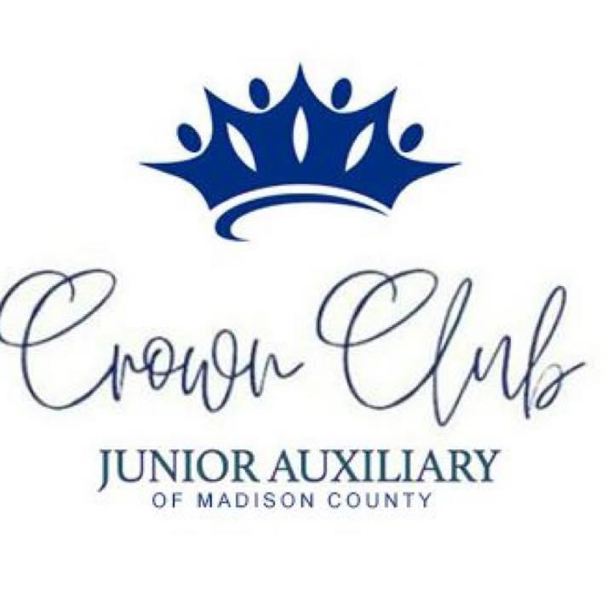

**Code of Conduct for**

**Crown Club of Madison County, MS**

**(last modified June, 2024)**

**Crown Club of Madison County, MS** is fully committed to safeguarding and promoting the wellbeing of all its members. The club believes that it is important that members, administrators and parents associated with the club should, at all times, show respect and understanding for the safety and welfare of others. Therefore, members are encouraged to be open at all times and to share any concerns or complaints that they may have about any aspect of the club with **Shalonda Carlisle, Crown Club Committee Chair.**

As a member of **Crown Club of Madison County, MS**, you are expected to abide by the following junior code of practice:

**MEMBERS ARE EXPECTED TO**:

1. Be loyal and give their fellow Club members a second chance or opportunity..
2. Be friendly and particularly welcoming to new Club members.
3. Be supportive and committed to other Club members, offer comfort when required.
4. Not get involved in inappropriate peer pressure and push others into something they do not want to do.
5. Keep within the defined boundary of the event area.
6. Behave and listen to all instructions from the Junior Auxiliary of Madison County Member(s).
7. Act within the rules and respect the Junior Auxiliary of Madison County Member(s) and their decisions.
8. Take care of all property owned by the Club.
9. All members must respect the rights, dignity and worth of all participants and beneficiaries regardless of age, gender, ability, race, cultural background or religious beliefs or sexual identity.
10. Refrain from the use of bad language or racial/sectarian references. This includes bullying using new technologies like chat-rooms or texting.
11. Members should punctually keep to agreed timings for events or inform their Junior Auxiliary of Madison County Member(s) if they are going to be late.
12. Members must wear designated Crown Club of Madison County, MS apparel/shirts to any and all Crown Club meetings and/or service projects.
13. Members must pay an annual membership fee – **currently $55.00 per year** (which includes designated Crown Club t-shirt.
14. Members are not allowed to smoke/vape or use any tobacco product at any Club meetings, events, or functions.
15. Members are not allowed to consume alcohol or drugs of any kind on the Club premises or while representing the Club.
16. Keep themselves and beneficiaries safe.
17. Report inappropriate behavior or risky situations for youth members.
18. Challenge or report the bullying of your peers.
19. Respect yourself and one another.
20. Not use violence or bringing to any Club function dangerous or unauthorized  
    materials such as explosives, firearms, weapons or other similar items.
21. Make your Club a fun place to be.
22. Lead by example and be good role models for the beneficiaries.
23. Be mindful of beneficiaries who are overly-friendly or attention-seeking. Maintain appropriate behavior and prevent having any physical contact with the beneficiaries.
24. Dress modestly and appropriately – no clothes which are skimpy, revealing, offensive, etc.
25. Regard the children/beneficiaries as any others and celebrate their talents and achievements.
26. Instill independence and self-confidence by providing guidance to the beneficiaries to complete the task by themselves, rather than always doing things for them.
27. Give compliments or feedback to Junior Auxiliary of Madison County Member(s) on positive or adverse encounters during the duration of the voluntary duties
28. Report immediately to Junior Auxiliary of Madison County Member(s) when you hear of any information from the beneficiary that is of potential threat or harm to self and/or others.
29. Protect of Confidential Information:
    1. All information confidential to the club, especially personal data of the beneficiaries and families must not be disclosed or used for any other purposes except as reasonably necessary to enable the volunteer to fulfil his//her voluntary responsibilities with the Club.
    2. Photographs and videos are considered personal data of the person photographed or filmed. If the volunteer would like to take photographs or videos with the beneficiary or family members, consent is required to be sought from them on a private and personal arrangement. However, volunteers should avoid asking those who have already been identified as not wanting to be photographed or filmed.

**MEMBERS HAVE THE RIGHT TO:**

1. Be safe and happy in their chosen activity.
2. Be listened to.
3. Be respected and treated fairly.
4. Privacy.
5. Enjoy your Club activities in a protective environment.
6. Be referred to professional help if needed.
7. Be protected from abuse by other member or outside sources.
8. Participate on an equal basis, appropriate to their ability.
9. Be believed.
10. Ask for help.

Any misdemeanors and general misbehavior will be addressed by the immediate Junior Auxiliary of Madison County Member(s) and reported verbally to the designated person. Persistent misbehavior will result in dismissal from the Club.

Dismissals can be appealed by the Junior Auxiliary of Madison County Member(s) with final decisions taken by the Club Chair or referred to the governing body depending on the disciplinary procedures within the Club.

Crown Club Member Name (Print):

__________________________________________________________

Member Signature:

______________________________________________

Date: _______________

Parent/Guardian Name (Print):

______________________________________________________________

Parent/Guardian Signature:

_______________________________________

Date: ____________________