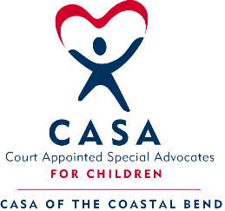

Privacy Policy and Acknowledgement of Responsibility

I understand and acknowledge that:
- It is my legal and ethical responsibility as an authorized user to preserve and protect the privacy, confidentiality and security of all confidential information relating to CASA of the Coastal Bend in accordance with applicable laws and program policy.
- I will access, use or disclose confidential information only in the performance of my duties, when required or permitted by law, and disclose information only to persons who have a right to receive that information. When using or disclosing confidential information, I will use or disclose only the minimum information necessary.
- I will discuss confidential information for work-related purposes only. I will not knowingly discuss any confidential information within hearing distance of other persons who do not have the right to receive the information. I will protect confidential information which is disclosed to me in the course of my relationship with CASA of the Coastal Bend.
- My access to all CASA of the Coastal Bend electronic information systems is subject to monitoring and audits in accordance with program policy.
- My User ID and password constitutes my signature and I will be responsible for all entries made under my User ID. I agree to always log off of shared or individual workstations.
- It is my responsibility to follow safe computing guidelines.
  - I may be personally responsible for any breach of confidentiality resulting from an unauthorized access to data on an unencrypted device due to theft, loss or any other compromise.
  - I will not share my User ID and password with any other person. If I believe someone else has used my User ID and password, I will immediately report the use to my supervisor and request a new password.
- Under state and federal laws and regulations governing a child’s right to privacy, unlawful or unauthorized access to or use or disclosure of a child’s confidential information may subject me to disciplinary action up to and including immediate termination from my relationship with CASA of the Coastal Bend], civil fines for which I may be personally responsible, as well as criminal sanctions.
By signing below:
- I attest that I have received training in confidentiality, privacy, security and what to do in the event of a breach.
- I attest that I have read, understand, and acknowledge all of the above statements and the acknowledgement of responsibility.

_______________________________________ Adopted by the CASA Board of Directors May 17,2016
Printed Name

_______________________________________ ________________________________________
Signature Date

