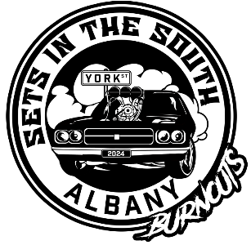

**EVENT SCHEDULE GUIDE**

**Friday**

* **9:00 am Gates Open/Bump In**
* **9:00am Scrutineering Opens**
* **11:00am Driver’s Brief**
* **11:30pm Possibility Open Pad (depending on entrant numbers)**
* **12:00pm Bar Open**
* **12:00pm Qualifying Rnd 1**
* **8:30pm Pad Close, Dual Burnout Demo’s (open pad subject to time)**
* **8:30pm Band**
* **12:00am Bar Closes**

**Saturday**

* **7:30am Late Entrant Scrutineering**
* **8:30am Driver’s Brief**
* **8:45am Last of Qualifying Rnd 1**
* **10:30am Qualifying Rnd 2 (subject to change depending on numbers)**
* **12:00pm Bar Open**
* **6:30pm Hopefully end of Rnd 2**
* **Open Pad (time permitting)**
* **7:00pm Finals**
* **Presentations**
* **8:30pm Band**
* **12:00am Bar Closes**

**Sunday**

* **Clean Up**

**NOTE: This is only a guide and subject to change but we will run as close to it as possible with the competition schedule taking priority over open pad.**