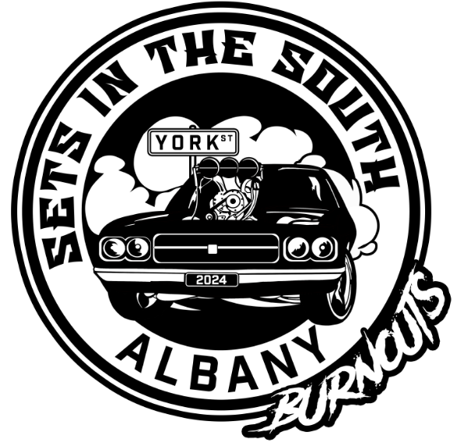

**RULES**

1. Sets In The South is brought to you by a sub committee of the West Oz Burnout Series formed to reinvigorate the burnout scene in Albany and the lower great southern. As such you will see a lot of similarity to the series rules.

2. Judging will consist of three judges scores, ideally from different angles around the pad (where safety permits). All judges scores out of a possible 100 will be tallied for a total of a possible 300.

3. The ten highest scores from the combination of the two qualifying rounds burnouts for each class will make up the finalists. If for some reason a finalist can’t compete it will be up to the event organiser if they fill that position with the next in line. Alternatively if there isn’t enough to make up a top ten in a class the entrants will have to at least driven on to the pad to qualify for finals.

4. Qualifying rounds will be a maximum of 2:00 and at that point if the car still has tyres on the rear it will be penalised per tyre still on

5. In the event a car begins to leak fluids on the track or catches fire the track marshal will switch the amber flashing lights on and other marshals will be signalling the car to stop. If the car deliberately doesn’t stop the entrant will be reprimanded and at a minimum not allowed to compete any further at that event. This is a safety directive and not negotiable.

6. Given the amount of competitors seen of late we will need to close off round one competition Mid Saturday morning (this is a floating target and will be gauged from Friday’s session progress and overall entrant numbers, but will be announced repeatedly and again not negotiable) You will simply miss that rounds score if you don’t make yourself available to compete in a timely manner.

7.In the rare case there is a draw in either qualifying or finals scores the judges will be asked to deliberate, given this is the fairest way to decide.

8. In the interests of transparency all scores will be displayed and breakdowns will be available on request.

9. The scorecard will be a standardised format across all comps and inline with the majority of comps in WA. It will be available on the web page for entrants as well a breakdown of the criteria and any questions can be directed to the page or raised at the drivers brief at the comp.

10. Multiple drivers for the same car are allowed but it is up to them to cover whichever number isn’t in use for that burnout so there is no confusion from the judges perspective as all scores and classes are recognised from that unique number. You can also nominate for multiple classes if you so choose and fit within the criteria below, but again you will need to cover the number not in use for that specific skid and compete in the right class at the right time.

11. There will be 6 Cylinder, 8 Cylinder and Blown classes at Sets In The South. Any form of forced aspiration will push you up a class (eg. 6cyl to 8cyl) or blown if you choose, (8cyl to Blown)  You must have some form of forced induction fitted and functional to nominate up. All fuel types are permitted in all classes.

12. Scrutineering requirements will be as per AASA current regulations and the approved WOBSSF1 scruitineering form. If your car meets these minimum standards you will be accepted at all competitions within the West Oz Series. You will also need to have a Valid AASA General Speed License or day license.

10. The predetermined Prize Money, any associated gifts and trophy for each class Top 3 places will be awarded on the night and EFT’s organised.

11. This event like the series is about having fun and growing the sport within the country, as such there will be no unsportsmanlike conduct tolerated towards the event, event promoters or other competitors either in person or on social media. If you are seen to be involved in any unsportsmanlike conduct you will be forced to leave the event and excluded from the series for a period in line with your offence and forfeit your nomination fee.

12. If in the unlikely scenario there is a genuine reason to lodge a dispute over issues such as class nominations (eg. use of forced aspiration in 6 or 8 instead of Blown) or judging results for example, a protest avenue with an associated $500 fee will be available. The series board members will investigate and if there is found to be any foul play or wrong doing appropriate action will be voted upon and utilised, however if there is no fault to be found you fee will be forfeited.

**Having read this and signing your entry form you acknowledge and agree to the above rules and conditions.**