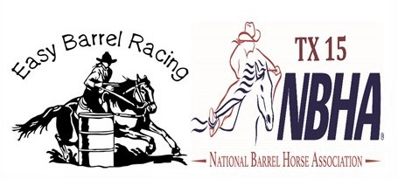

NBHATX15/Easy Barrelracing 2025 Sponsorships
Sponsor to supply Banner (If needed, we can get you in contact with our banner maker)

Company Banner in arena (4X3 banner) $400.00
(Limited to 20 banners)

All sponsors will be on the NBHATX15.com website
All sponsors will be announced at all races throughout the race
All sponsors will be listed and tagged on Facebook.
Payment options of cash, check, Paypal or Venmo
Please contact Susan Ogden-Mckee at 940-577-5433 for additional information

