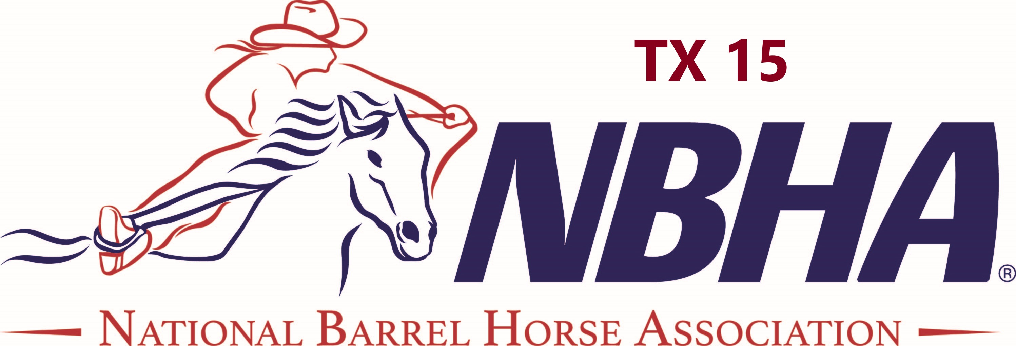 NBHA TX 15 2020 ENTRY FORM (one per contestant)
Name: ___ Cell# DOB: ________ Member number:_______________Yes_____________No
Address: __________________________ City ____ ST:__ ZIP: Email: _____________________ __________
Horse Name  (Draw numbers will be drawn in the order listed) | NBHA Dist. Point Horse? | Draw# | OPEN  4D  $30 | SENIOR 3D  $30 | YOUTH 4D  $30 | 4D Adult  Sidepot  (19-49)  $20 | SR or YT Carry Over | Novice  $10  (no arena fee) | Entry Fee Subtotal
4.
Series nomination fee per horse per class $1.00 X _______ ENTRY FEE TOTAL
$1.00 per horse per class one time Nomination fee for series |  |  |  | # of Exhibition  _______ | @$5 ea
Bouns Race fee ($1.00 per horse in Open |  |  |  | #of horses in Open  ____ | @$1.00 ea
 |  |  |  | Arena Fee | $10.00 | $ 10.00
Initials | Cash |  | Check# |  | TOTAL DUE

INDEMNIFICATION AND RELEASE For Office Use:
Personal Injury - By signing this document and by making entry as a participant I hereby understand the inherent
risk of this sport. Furthermore, I as participant (or parent/guardian), agree to indemnify and hold harmless NBHA TX 15 and it’s officers, agents, management, contractors, employees and volunteers free from any known or unknown liabilities, injury, death, claim, expense (including legal fees), cause of action, or damage of any kind whatsoever which might be asserted by me, on my behalf, or my child’s behalf.
Property Loss Or Injury - I further agree to indemnify and hold harmless NBHA TX 15 and aforementioned parties for any injury or death of any animal and/or loss, disappearance, theft or damage to any property while in
or upon the premises of a NBHA TX 15 sponsored event.
Age Certification - By the appearance of my signature, indicated below, I certify that I am 18 (eighteen) years of
age or older, or that I am the parent or legal guardian of the participant/entrant who is under the age of 18 (eighteen).
Coggins (EIA) Test - I further certify that I have available at the request of Silver Saddle 4-H club, State and/or Local Authorities, event producer, facility owner/manager a Negative, current to date, Coggins (EIA) Test on EACH animal that I bring on event grounds. I understand that if NBHA TX 15, State and/or Local Authorities, event producer, facility owner/manager require presentation of said test records and I cannot present a NEGATIVE COGGINS (EIA) TEST per any one (1) animal. I will be personally responsible for any fine, fees and/or cost related to this violation and further, will indemnify and hold harmless NBHA TX 15, event producer, or facility owner/manager for any said fees or costs and/or fines incurred.

SIGNATURE OF PARTICIPANT or LEGAL GUARDIAN ENTRANT IF UNDER 18 (Please print) NAME OF PARTICIPANT/ENTRANT DATE

