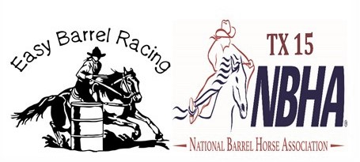

NBHATX15/Easy Barrelracing 2024 Sponsorships

Sponsor to supply Banner (If needed, we can get you in contact with our banner maker)

Company Banner in arena (4X3 banner) $400.00

Logo on 1 barrel – no banner $600.00

Banner and logo on one barrel $800.00

Banner and Logo on two barrels $1000.00

Banner and Logo on all three barrels $1500.00

All sponsors will be on the NBHATX15.com website

All sponsors will be announced at all races throughout the race

All sponsors will be listed and tagged on Facebook.

Payment options of cash, check, Paypal or Venmo

Please contact Susan Ogden-Mckee at 940-577-5433 for additional information