2020 Sponsorship Receipt | 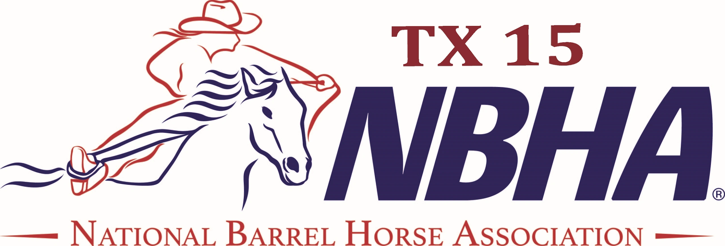
web: https://nbhatx15.com/
email: nbhatxdistrict15@gmail.com
Company Name: _________________________________________________
Name of Contact _________________________________________________
Telephone/Email: _________________________________________________
Amount of Sponsorship: ________________ Date received: _____________
Sponsorship Selection(s):
᐀ Gold - $5000 | ᐀ Banner - $250 | Barrel Wraps: | ᐀ 1 Logo - $100  ᐀ 3 Logos - $250 (1 on ea barrel)  ᐀ 6 Logos - $400  6 Logos or 2 full panels with 3 logos (2 barrels)  ᐀ Full Barrel Sponsor  Only YOUR logo + NBHA logo in one spot or 1 full panel (3 logos) on each of 3 barrels.
᐀ Silver - $2500 | ᐀ Saddle - $1000
᐀ Bronze - $1500
Method of Payment: ___Cash ___ Check (Check# :__________) ____Paypal
Sponsor’s Signature: ____________________________________ Date: _________
NBHA Signature: _______________________________________ Date: _________
- - - - - - - - - - - - - - - - - - - - - - - - - - - - - - - - - - - - - - - - - - - - - - - - - - - - - - -
Sponsor Receipt ​(detach above)
Name of Sponsor: _________________________________
Amount of Sponsorship: ___________________________ Date: ________
NBHA District 15 Representative: ________________________ Date: ________

