2022 Sponsorship Receipt | 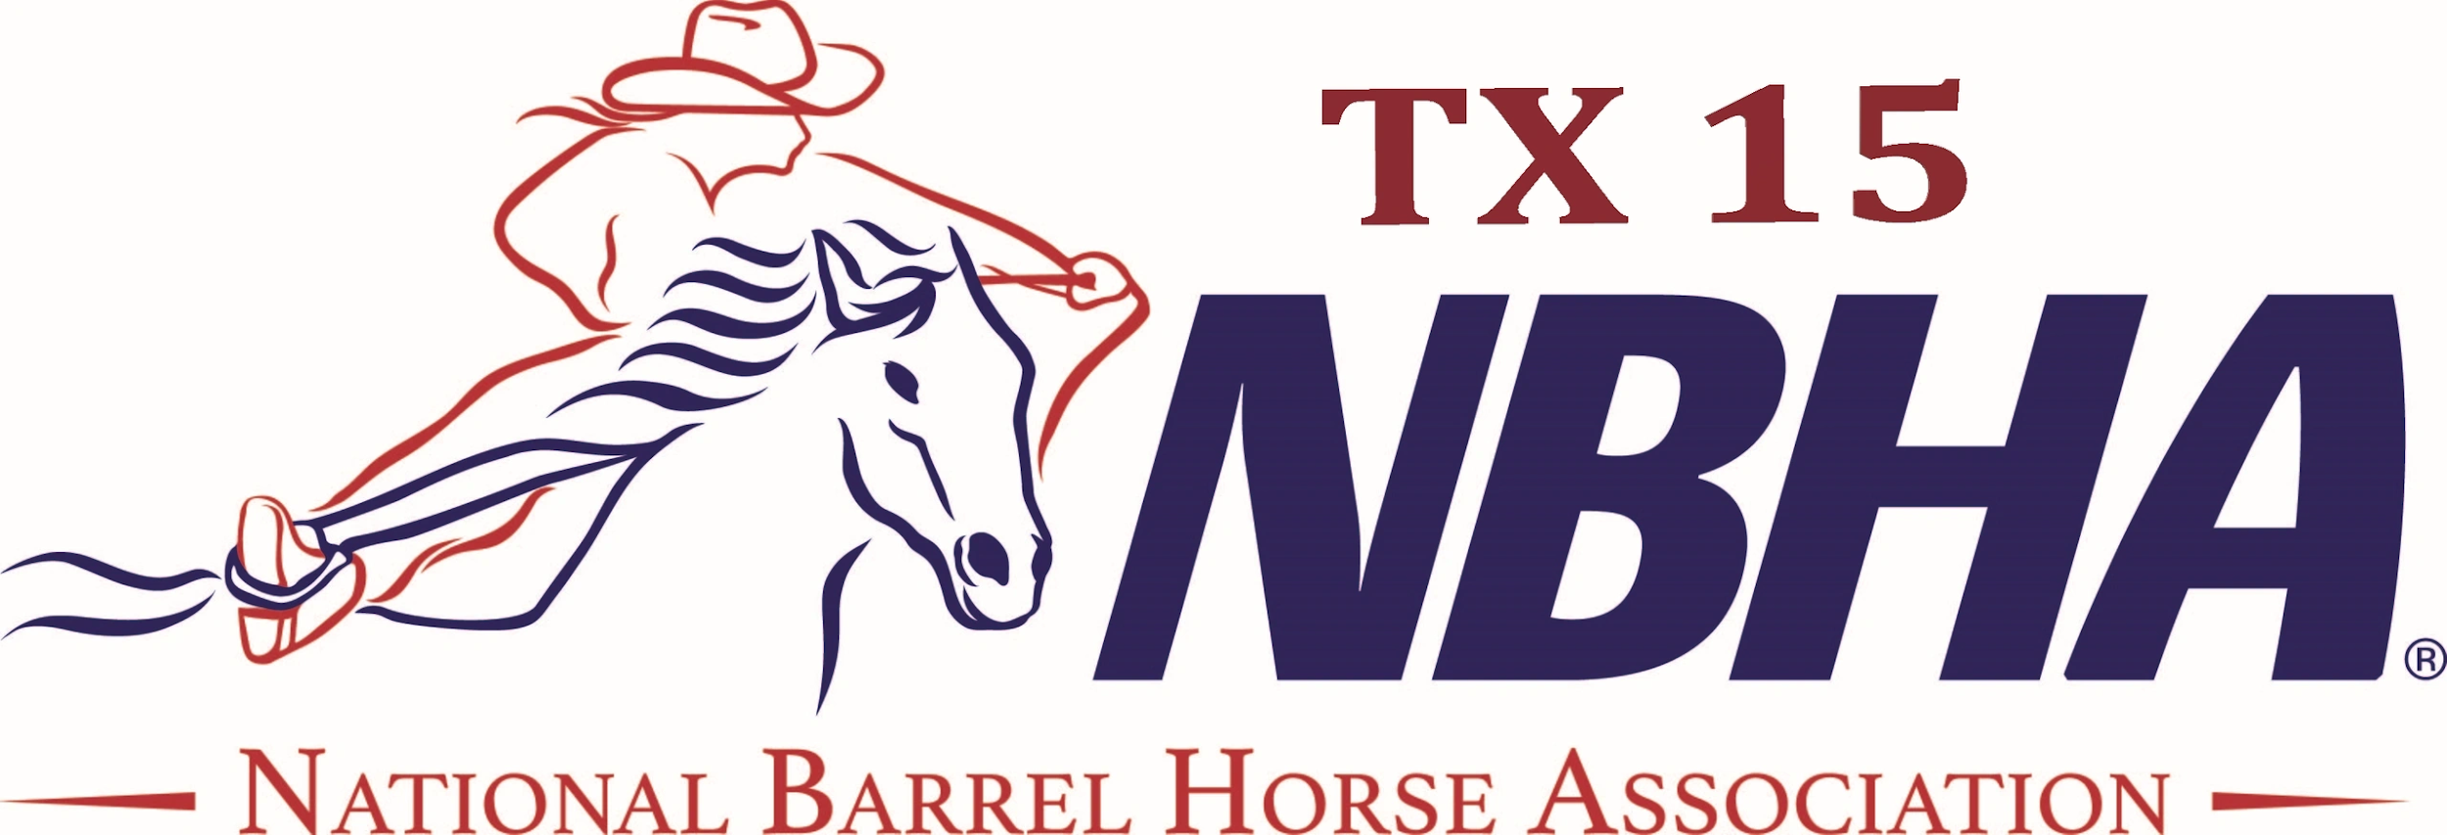
web: https://nbhatx15.com/
email: nbhatxdistrict15@gmail.com
Company Name: _________________________________________________
Name of Contact _________________________________________________
Telephone/Email: _________________________________________________
Amount of Sponsorship: ________________ Date received: _____________
Sponsorship Selection(s):
__ Banner - $500 |  |  | Races for the 2022 season will be ran in conjunction with Easy Barrel Racing. Sponsorships will be split equally between both organizations.  *Sponsors will be put on NBHA TX15 website.  *Shouts throughout races.  *Facebook Tags
__ $1000 | Finals race added money (last race of year)
____$1500
____$2000

Method of Payment: ___Cash ___ Check (Check# :__________) ____Paypal
Sponsor’s Signature: ____________________________________ Date: _________
NBHA Signature: _______________________________________ Date: _________
- - - - - - - - - - - - - - - - - - - - - - - - - - - - - - - - - - - - - - - - - - - - - - - - - - - - - - -
Sponsor Receipt ​(detach above)
Name of Sponsor: _________________________________
Amount of Sponsorship: ___________________________ Date: ________
NBHA District 15 Representative: ________________________ Date: ________

