HEALTH AND SAFETY POLICY
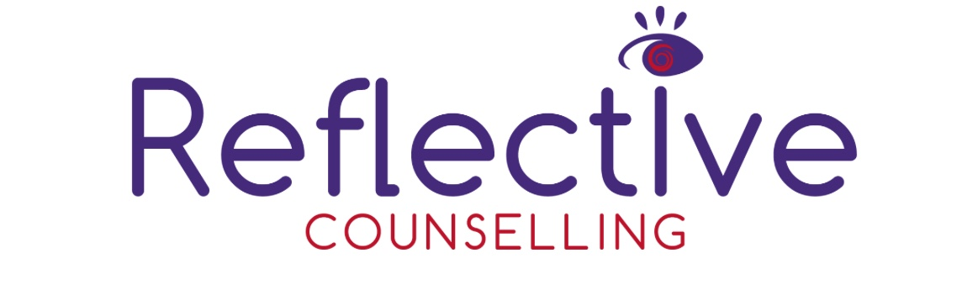
General Statement of Policy, Duties & Responsibilities

Policy Statement

Reflective Counselling recognises and accepts its health and safety duties for providing a safe and healthy working environment (as far as is reasonably practicable) for all its workers (paid or volunteer) and clients to its premises under the Health and Safety at Work Act 1974, the Fire Precautions (Workplace) Regulations 1997, the Management of Health and Safety at Work Regulations 1999, other relevant legislation and common law duties of care.
Throughout this Statement, terms such as “staff”, “workers”, “employees”, include both paid and volunteer workers.
It is the policy of Reflective Counselling to promote the health and safety of the staff, volunteers and clients who visit the premises and to intent to

- Take all reasonably practicable steps to safeguard the health, safety and welfare of all personnel on the premises
- Provide adequate working conditions with proper facilities to safeguard the health and safety of personnel and to ensure that any work which is undertaken produces no unnecessary risk to health or safety
- Encourage persons on the premises to co-operate in all safety matters, in the identification of hazards which may exist and in the reporting of any condition which may appear dangerous or unsatisfactory
- Ensure the provision and maintenance of equipment and systems of work that are safe
- Maintain safe arrangements for the use, handling, storage and transport of any articles;
- Provide sufficient information, instruction and supervision to enable everyone to avoid hazards and contribute to their own safety and health
- Provide specific information, instruction, and supervision to personnel who have particular health and safety responsibilities (Report to owner)
- Make, as reasonably practicable, safe arrangements for protection against any risk to health and safety of the general public or other persons that may arise
- Make suitable and sufficient assessment of the risks to the health and safety of employees and of persons not in the employment
- Make specific assessment of risks in respect of new or expectant mothers and young people under the age of eighteen
- Provide information to other owner of any risks

Statutory Duty of Reflective Counselling

Reflective Counselling will comply with its duty to ensure, as far as is reasonably practicable, the health, safety and welfare at work of its workers, students and clients to
- Make workplaces safe and without risks to health
- Ensure any equipment is safe and that safe systems of work are set and followed;
- Ensure articles and equipment are moved, stored and used safely;
- Give staff/students the information, instruction and supervision necessary for their health and safety

In particular, Reflective Counselling will

- Assess the risks to health and safety of its staff, students and clients
- Make arrangements for implementing the health and safety measures identified as necessary by this assessment
- Record the significant findings of the risk assessment and the arrangements for health and safety measures
- Draw up a health and safety policy statement; including the health and safety organisation and arrangements in force, and bring it to the attention of its workers
- Set up emergency procedures
- Provide adequate First Aid facilities
- Make sure that work equipment is suitable for its intended use as far as health and safety is concerned, and that it is properly maintained and used
- Prevent or adequately control exposure to substances that may damage health
- Take precautions against danger form flammable or explosive hazards, electrical equipment, noise or radiation;
- Avoid hazardous manual handling operations and, where they cannot be avoided, reduce the risk of injury
- Ensure that appropriate safety signs are displayed and maintained;

Statutory Duty of the Staff and Students

Staff and students also have legal duties

- To take reasonable care for their own health and safety, and that of other persons who may be affected by what they do or do not do
- To co-operate with Reflective Counselling on health and safety
- To use work items provided correctly
- Not to interfere with or misuse anything provided for health, safety and welfare purposes
- To report at the earliest opportunity injuries, accidents or dangerous occurrences at work, including those involving the public

Clients

On arrival all clients are the responsibility for staff/student and in an emergency, they should assist the client out of the building in the event of a fire or any other incident where evacuation is necessary.

Organisation of Health and Safety

Health and Safety Rules

All staff and students must exercise ordinary care to avoid accidents in their activities at the premises and comply with the following general rules

Alcohol, Drugs and Tobacco
Smoking within the premises and the use of Drugs on the premises are prohibited at all times. The use of intoxicants (alcohol) is strictly prohibited during working/course hours, and no Staff/Student may undertake their duties if under the influence of alcohol or drugs (except under medical supervision).

This policy was updated 03/12/25
This policy will be updated 03/12/26

