SAFEGUARDING POLICY

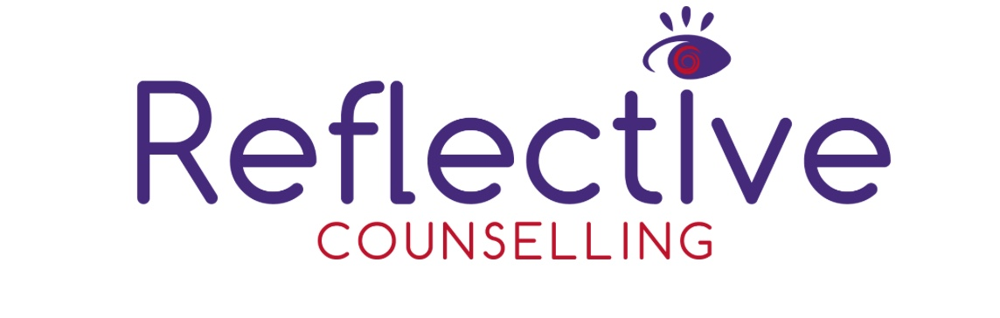

Safeguarding is ‘everyone’s responsibility.  This policy sets out Reflective Counselling’s responsibilities to ensure that adults at risk are kept safe from harm. This may include ‘The conduct of counsellors associated with Reflective Counselling.’

We have an overarching commitment to keep at risk adults safe at all times whilst under our care and supervision.

The Policy

The policy lays out the commitments made by Reflective Counselling and informs counsellors of their responsibilities in relation to safeguarding.

This policy does not include safeguarding concerns in the wider community that are not perpetrated by Reflective Counselling.

What is Safeguarding?

In the UK, safeguarding means protecting peoples' health, wellbeing and human rights, and enabling them to live free from harm, abuse and neglect.

We understand it to mean protecting people i.e., adults at risk from harm that arises from coming into contact with our counsellors. This includes all staff contracted by Reflective Counselling.

Policy Statement

Reflective Counselling believes that every client we come into contact with, regardless of age, gender identity, disability, sexual orientation or ethnic origin has the right to be protected from all forms of harm, abuse, neglect and exploitation. We have a responsibility to promote the welfare of all our clients, to keep them safe and to practise in a way that protects them and their interests.

​

This policy will address adult safeguarding.

Reflective Counselling commits to addressing safeguarding throughout its work, through the three pillars of prevention, reporting and response.

Prevention

Reflective Counselling Responsibilities

* Ensure all counsellors have access to, are familiar with, and know their responsibilities within this policy
* This includes information about clients, how it is gathered, communicated and stored
* Implement stringent safeguarding procedures when recruiting
* Follow up on reports of safeguarding concerns promptly and according to due process

Counsellor Responsibilities

Adult/Teens safeguarding

Reflective Counselling will adhere to the following

* We will not subject an at-risk adult to physical, emotional or psychological abuse, or neglect
* Ensure the welfare of all clients, their wishes and feelings are always considered
* Contribute to creating a safe space that prevents safeguarding violations
* Report any concerns or suspicious regarding safeguarding

​

Reporting

Reflective Counselling will ensure that safe, appropriate, accessible means of reporting safeguarding concerns are made available to counsellors and the communities we work with. If circumstances allow, we will communicate this reporting to the client.

Response

Reflective Counselling will follow up safeguarding reports and concerns according to policy and procedure, and legal and statutory obligations.

Reflective Counselling will apply appropriate disciplinary measures to staff found in breach of policy.

​

Confidentiality

It is essential that confidentiality in maintained at all stages of the process when dealing with safeguarding concerns.  Safeguarding information will be stored and handled in line with the Data Protection Act 2018.  Information relating to the concern and subsequent case management should be shared on a need-to-know basis only and should be kept secure at all times. 

Contact Details

In the first instance, please contact [reflectivetherapy@hotmail.com](mailto:reflectivetherapy@hotmail.com) for any further support and advice relating to the above.

​

Glossary of Terms

Beneficiary of Assistance

Someone who directly receives goods or services from Reflective Counselling.

Harm

Psychological, physical and any other infringement of an individual’s rights

Psychological harm

Emotional or psychological abuse, including (but not limited to) humiliating and degrading treatment such as bad name calling, constant criticism, belittling, persistent shaming, solitary confinement and isolation

Safeguarding

In the UK, safeguarding means protecting peoples' health, wellbeing and human rights, and enabling them to live free from harm, abuse and neglect

In our sector, we understand it to mean protecting people, including children and at-risk adults, from harm that arises from coming into contact with our staff or programmes.  One donor definition is as follows:

Safeguarding means taking all reasonable steps to prevent harm, particularly sexual exploitation, abuse and harassment from occurring; to protect people, especially vulnerable adults and children, from that harm; and to respond appropriately when harm does occur.

This definition draws from our values and principles and shapes our culture. It pays specific attention to preventing and responding to harm from any potential, actual or attempted abuse of power, trust, or vulnerability, especially for sexual purposes.

Safeguarding applies consistently and without exception across our programmes, partners and staff. It requires proactively identifying, preventing and guarding against all risks of harm, exploitation and abuse and having mature, accountable and transparent systems for response, reporting and learning when risks materialise. Those systems must be survivor-centred and also protect those accused until proven guilty.

Safeguarding puts beneficiaries and affected persons at the centre of all we do.

​

Sexual abuse

The term ‘sexual abuse’ means the actual or threatened physical intrusion of a sexual nature, whether by force or under unequal or coercive conditions.

​

Sexual exploitation

The term ‘sexual exploitation’ means any actual or attempted abuse of a position of vulnerability, differential power, or trust, for sexual purposes, including, but not limited to, profiting monetarily, socially or politically from the sexual exploitation of another.  This definition includes human trafficking and modern slavery.

​

Survivor

The person who has been abused or exploited. The term ‘survivor’ is often used in preference to ‘victim’ as it implies strength, resilience and the capacity to survive, however it is the individual’s choice how they wish to identify themselves.

At risk adult

Sometimes also referred to as vulnerable adult.  A person who is or may be in need of care by reason of mental or other disability, age or illness; and who is or may be unable to take care of him or herself, or unable to protect him or herself against significant harm or exploitation.

**This policy was updated 17/9/24**

**This policy will be updated 17/9/25**