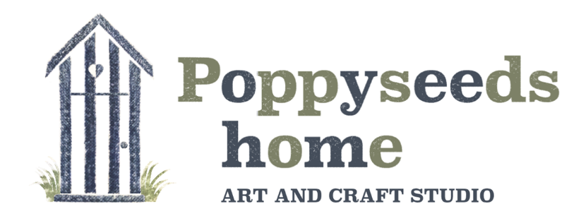

Terms and Conditions for Workshops

**Workshop Booking**

* All workshops are bookable in advance, with full payment due at the time of the booking.
* When booking a workshop, it is understood that you have read and agreed to our terms and conditions.

**Poppyseeds home definition of a workshop**

We are a small independent company and registered as a limited company; we are a retail and educational setting where we provide workshops and parties that a tutor delivers by modelling the skill and giving verbal and visual instructions. We provide enriching activities where we promote social interactions within the group, thus promoting inclusion, well-being, and creative learners.

**Venue**

* Our lovely studio is situated in the garden of the owner of Poppyseeds home
* Any play equipment or garden furniture in the garden is strictly out of bounds.
* We are in a residential area, please park with consideration. Do not block our neighbours’ driveways or park on the pavements.
* We washroom facilities.

**Timings**

* We will begin our workshops prompt; please ensure you arrive at the studio at least 10 minutes before your start time, to get settled.

**Cancellations**

* If you need to cancel your Workshop booking, please ring us asap and advise us in writing clearly stating your reason.
* We will endeavour to re-book you onto the next available (same) course and transfer your payment over.
* We do not offer any refunds or credit notes for part of a workshop, such as leaving early or where the workshop in several visits. However, we will try to accommodate a re-booking of the same course you originally booked if spaces allow.
* If we need to cancel a workshop due to the tutor being ill, you will be given a full refund via the method you paid.
* If a government lockdown/change in guidelines is enforced due to Covid-19 or any other government circumstance and your booking cannot go ahead, then we will offer you a new date once restrictions are lifted. If a new date cannot be rebooked for example the workshop is a seasonal workshop, then you will be given a credit note for the full value of your workshop to be used within 12 months of the date of issue.

**Photography**

Poppyseeds home would love to take photos of you and your children whilst they are crafting in our studio. However, we take the safeguarding of children very seriously; we will not do so without the agreed consent of parents/guardians and child. (Please see our safeguarding policy).

We will always ask your permission before taking photos. Customers should not feel any pressure to consent - photographs of your creations can be taken without you being in the shot.

**Please note;** Aprons will be provided to protect clothing, However, due to the ingredients in some of the products used, some staining may occur if they are accidentally spilt on clothes. Poppyseeds home will not be held liable for any damage to clothing and advise customers to dress appropriately. Poppyseeds home will not be held liable for any personal belongings that are damaged or stolen whist on their premises. It is advised that mobile phones are not left out on the crafting table. Thank you.

**\*By booking onto one of our workshops, it is understood that you have read our terms and conditions and all other relevant policies. We have provided all the information for you on our website, Poppyseeds home would like to remind its customers that it is their responsibility to ensure policies are read prior to booking and adhered to throughout the workshop experience.**

Poppyseeds home Limited

218 Common Road,

Bedfordshire

LU6 2PJ

07921025788

poppyseedshome@yahoo.com