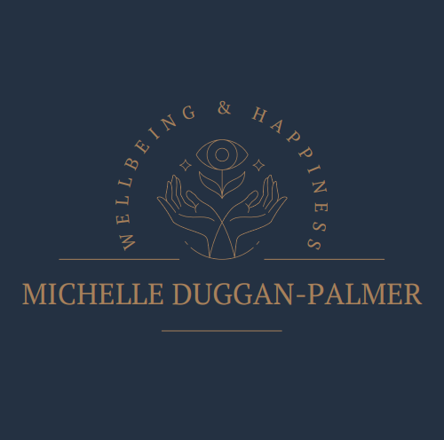

Coronavirus Policy

At what continues to be a very worrying time for us all, keeping our children and
families safe is our highest priority.

It is vital that we remain vigilant and work together to reduce the risk of infection.

In addition to following national and local measures, I have outlined below the
procedures that need to be followed when children are attending my sessions for the protection of everyone involved.
These procedures will remain in place whilst the Coronavirus Pandemic remains a
threat to our health and society.
I would be most grateful if you could support me in implementing these measures in the interests of safety for all children and families.

Drop off and Collection

Please drop your child at the door where possible, if your child is hesitant, I would ask you to wear a face mask when entering my home.
Shoes and outside coats will be taken off at the door.
Hand gel will be supplied and used upon arrival, or your child or young person can
use their own.

Hygiene

I will ensure tissues are available and a lidded bin provided.
I will ensure that surfaces are cleaned using antibacterial spray or wipes just before your child or young person’s session.
Please can I ask that no additional toys from home are bought to the session.
Any equipment that I use will be cleaned down after each use with antibacterial spray
I will ensure good ventilation within the room by keeping windows open.
I will not be able to offer drinks throughout the session therefore please bring a water bottle.

Social Distancing

The furniture in the room is arranged so that we can keep to the 2 metre rule as
much as possible.

Illness and Infection

Parents must inform me of any other educational settings their child is attending
so that in the event of a suspected or confirmed case of coronavirus, I can pass
on required information to the NHS Test and Trace / Test and Protect service.
I will ask all families to follow the COVID-19: guidance for households with
possible coronavirus infection guidance should a child, parent or any other
member of their household display symptoms or discover that they have been in
close contact with a confirmed case of coronavirus. Please do not attend the
session and contact the test and trace service to request a test as soon as
possible.
NHS Test & Trace: www.gov.uk/get-coronavirus-test Telephone: 119
Your child will not be able to attend sessions for the duration of the
recommended isolation period or until a negative test result is received. The sessions
can be re-arranged when all is well at no additional cost.
This is essential for the protection of everyone else who attends my practice and the
safety of my own family.
• If I, or anyone else within my household display symptoms or come into contact
with a confirmed case of coronavirus, government advice will be followed. I will
notify families immediately and close my sessions for the duration of the isolation
period.
• In the event of any confirmed or suspected case of coronavirus I will follow
notification procedures and support the governments test and trace system. This
may require passing your details onto relevant organisations.

If you have any questions regarding coronavirus management procedures, please do not hesitate to ask me.

Best Wishes,

Michelle Duggan-Palmer

