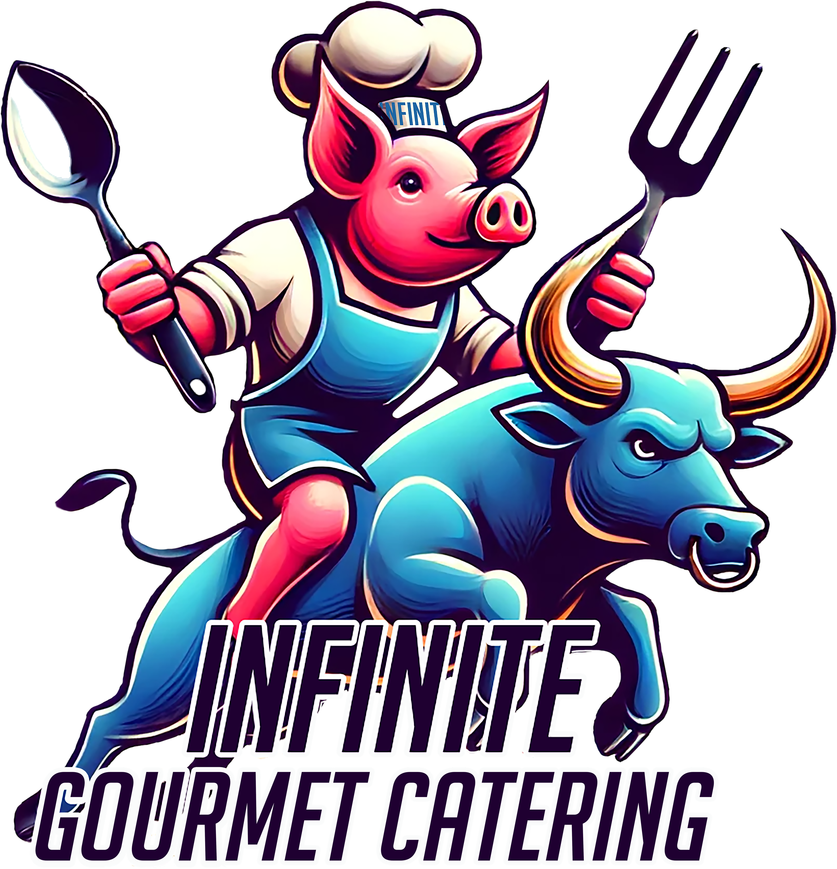
CATERING
Must be ordered minimum of 10 days in advance – 20 person or $1000 Minimum
Price is Per Person – When Creating Your Menu, the Prices May be Discounted

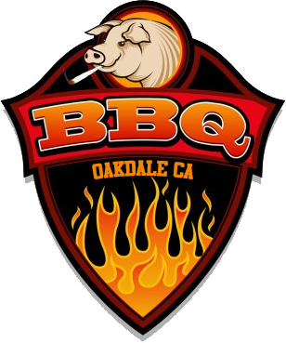Hors D'oeuvres
Seasonal Crostini $5 · Assorted Cheese Board $5 · Charcuterie Board $7 · Seasonal Fruit Tray $6
Bacon Wrapped Prunes $5 · Caprese Salad Skewers $5 · Stuffed Mushrooms $5 · Chicken Wings $5
BLT Sliders $5 · Chicken Nugget $5 · Pot Stickers $5 · Chicken Satay w/Peanut Sauce $6
Saratoga Chips $3 · Ham & Cheese Sliders $3 · Mini Biscuits w/Ham & Pepper Jelly $4 · Bagels $5
Skewered Steak w/Chimichurri $5 · Popcorn Chicken Bites $5 · Hamburger Sliders $5 · French Fries $6
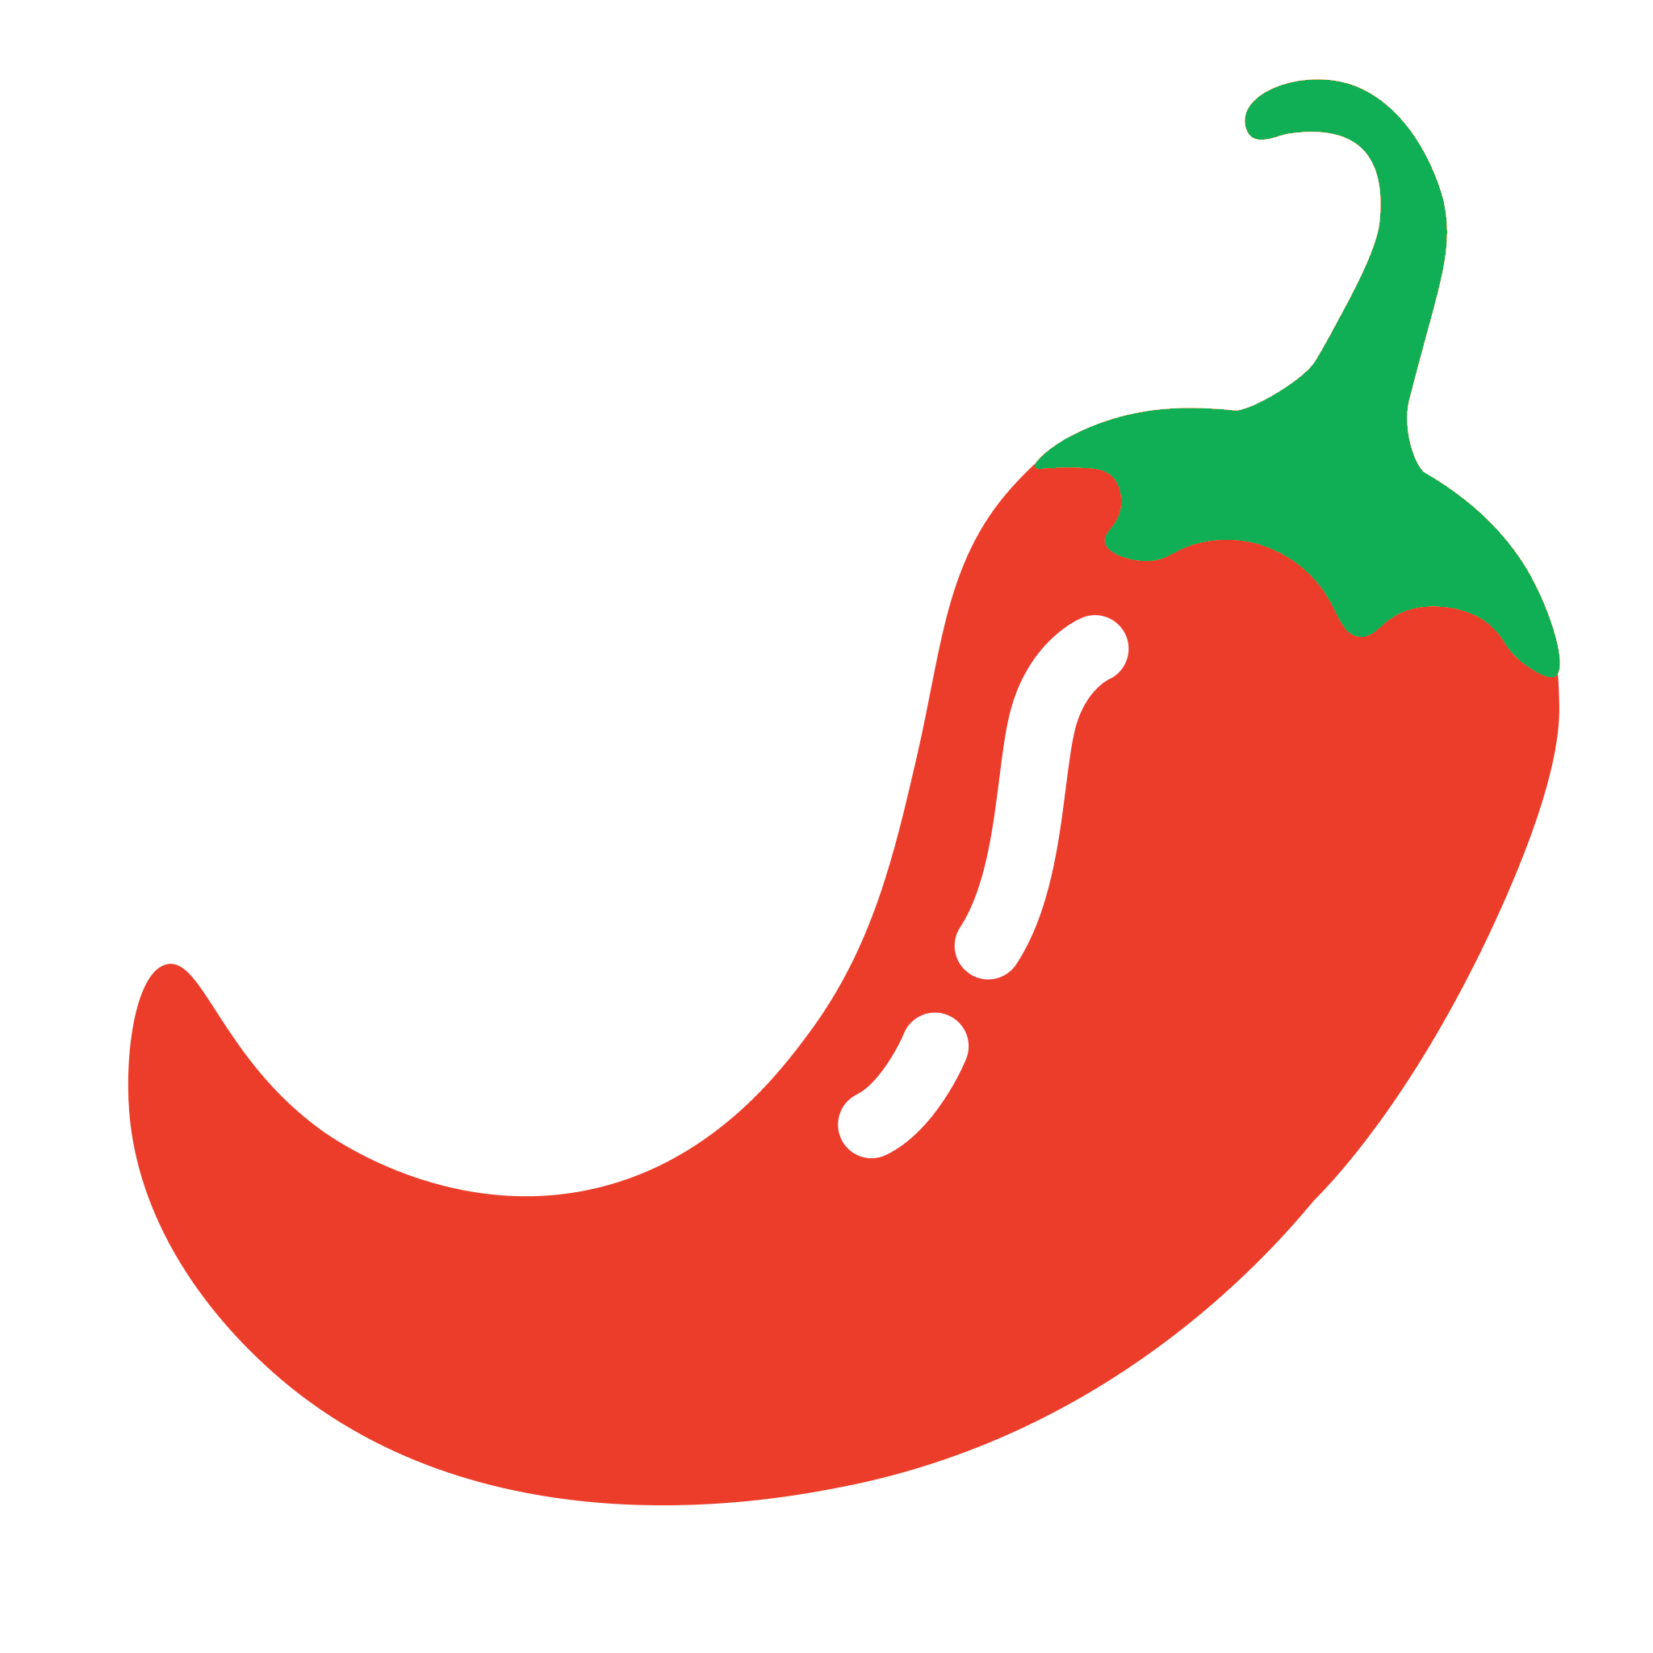
Chicken Sliders $5 · Shrimp Skewers $7 · Thai Chicken Wraps $5 · Soft Pretzels $5 · Onion Rings $7
Kimchi $6 · Cucumber Kimchi $5 · Grilled Jalapeno’s $3 · Stuffed Brisket Jalapeno’s $7
Shrimp Cocktail Shots $5 · Mini Grilled Cheese $4 · Thai Deviled Eggs (Spicy) $4 · Chips & Salsa $6
Lollipop Chicken Legs $5 · Smoked Meatballs $4 · Pulled Pork Sliders $5 · Nachos $6 · Vegetable Tray $7
Bruschetta w/Baguettes $3 · Cheese Quesadilla $4 · Rolled Tacos $4 · Mini Chicken Tacos $6
Spinach Dip w/French Bread $6 · Loaded Potato Skins $7 · 7 Layer Bean Dip with Chips $6
Toasted Ravioli $7 · 7-Layer Bean Dip w/Chips $6 · Guacamole and Chips $7 · Fried Pickles $6
Mexican Corn Dip w/Chips $6 · Mozzarella Cheese Sticks $7 · Carne Asada Fries $7 · Jalapeno Poppers $6
Mini Fully Loaded Baked Potatoes $6

GRAZING TABLE
Brie Cheese $3 · Manchego Cheese $3.5 · Gorgonzola Cheese $2 · Aged Cheddar $2.5 · Goat Cheese $3
Smoked Cream Cheese $4 · Pepper Jack Cheese $2 · Prosciutto $4 · Soppressata $3 · Capicola $3
Salami $2 · Sliced Ham $3 Sliced Turkey Breast $3 · Sliced Roast Beef $2 · Baguette Slices $1.5
Ciabatta $1.5 · French Bread $1.5 · Pita Bread $1.5 · Sourdough Bread $1.5 · Wheat Bread $1.5
Rye Bread $1.5 · Multigrain Bread $1.5 · Italian Bread $1.5 · White Bread $1.5
Hummus $1 · Olives $0.5 · Grilled Jalapeños $1 · Steak Bites $3.5 · Cabbage Kimchi $2
Cucumber Kimchi $2 · Million Dollar Bacon $3 · Grilled Sweet Peppers $1.5 · Mini Chicken Tacos $2
Mini Cupcakes $1.5 · Mini Lemon Bars $2 · Mini Fruit Cup $2.5 · Mini Individual Salads $3
Gourmet Sandwich Bar with 3 Meat/Cheese/Bread Options $15 · Sliced Tomatoes $1.5 · Sliced Onion $0.75
Iceberg Lettuce $1 · Romain Lettuce $1 · Pepperoncini $0.75 · Sliced Cucumber $0.75
Mini Grilled 3 Cheese Sandwich $2.5 · Arugula $1 · Sun Dried Tomatoes 1.5 · Avocado Slices $2.5
Capers $1 · Sprouts $1 · Fresh Herbs $1.5 · Pesto Sauce $1 · Aioli $0. 5 · Whole Grain Mustard $0.5

Charcuterie boards
Standard Charcuterie Board $7 · Charcuterie Cones $8 · Vegan Charcuterie Board $8 · Breakfast Board $8
Jarcuterie Board $9 · Dessert Charcuterie $8 · Charcuterie Skewers $8 · Seafood Charcuterie $12
Butter Board $8

SALADS
Caesar Salad $5 · Cole Slaw $4 · Cobb Salad $6 · BLT Salad $5 · Broccoli Salad $5 · Cucumber Salad $5
Arugula Salad w/Almonds and Apples $5 · Garden Salad $4 · Baby Green w/Walnut and Green Apple $6
Potato Salad $4 · Macaroni Salad $4 · Seaweed Salad $6 · Green Salad w/Chicken and Apple $5.5
Green Salad $5 · Green Salad w/Steak Strips $7.5
*Salad Dressings: Ranch, Spicy Ranch, Thousand Island, Blue Cheese, Balsamic Vinaigrette, Honey Mustard, Caesar, Cilantro Lime, Raspberry Vinaigrette, and Italian.

wood fired pizza

Pizza size 8”- $250 Setup fee -cook onsite
Garlic Bread Sticks $3 · Wood Fired Artichokes $4 · Wood Fired Bruschetta $4 · Cheese Pizza $13
Margherita Pizza $14 · Pepperoni Pizza $14 · Hawaiian Pizza $14 · Vegetarian Pizza $14
BBQ Chicken Pizza $16 · Buffalo Chicken Pizza $16 · Combination Pizza $16 · Ham & Jalapeno Pizza $16
Chicken & Green Apple Pizza $16 · Sausage and Mushroom Pizza $16 · Linguica Pizza $16
Carnivore Pizza $16 · Chicken Bacon Pizza $16 · Chicken Alfredo Pizza $18 · Quattro Formaggi Pizza $16
Kimchi Pizza $16 · Tri Tip Pizza $18 · Linguica Pizza $16 · Pork Belly Pizza $16 · Garlic Chicken $16
Nutella Pizza $16 · Apple Cinnamon Pizza $16 · Tiramisu Pizza $16 · Build Your Own $18

SoupS

soup Serving Size: ~8 oz
Lasagna Soup $5 · Tomato Basil Soup $5 · Vegetable Beef $5 · Seaweed Soup $6
Spicy Kimchi Soup $5 · Clam Chowder $6 · Egg Flower Soup $4 · Baked Potato Soup $5
Tofu Soup $5 · Minestrone Soup $5 · Chicken Noodle Soup $5 · Chicken Tortilla Soup $6
Broccoli Cheese Soup $5 · French Onion Soup $6 · Italian Wedding Soup $5
Soup in a Sourdough Bread Bowl $10

ENTREES

meat Serving Size: ~10 oz
Smoked Pulled Pork $10 · Smoked Tri Tip $19 · Smoked Brisket $18 · Baby Back Ribs $14
Grilled Rib Eye Steak $18 · St. Louis Style Ribs $14 · NY Steak $18 · Grilled Pork Chops $12
Brisket Burnt Ends $20 · ¼_{lb} Hamburger $9 · ¼_{lb} Hot Dogs $7 · Bacon Wrapped Pork Tenderloin $14
Korean Short Ribs $18 · Brisket Mac and Cheese $12 · Korean Beef Bulgogi $16 · Burnt Ends $20
Korean Spicy Pork $15 · Korean Pork Belly $14 · Meat Lasagna $12 · Smoked ½ Chicken $10
Grilled Chicken Breast $12 · Grilled Chicken Thighs $11 · Pulled Chicken $10 · Grilled Sausage $8
Pork Belly Burnt Ends $14 · Grilled Salmon $20 · Open Taco Bar $14 · Fettuccini Alfredo w/Chicken $12
Baked Ham $10 · Smoked Turkey $10 · Prime Rib $24 · Smoked Chicken Pot Pie $14
Country Fried Steak with Country Gravy $16 · Salisbury Steak $14 · Smoked Pork Loin $12
Sliced Roast Beef $16 · Smoked Meatloaf $14 · Pot Roast w/Potatoes and Carrots $14
Hearty Beef Stew $16 · Beef Tips and Rice $16 · Grilled Chicken Wraps $12 · Brisket Gyro $14
Meat Quesadilla $8 · Gourmet Grilled Cheese $7 · Deli Sandwich $10 · 2 Street Tacos $7 · Burrito $12
10” Brick Oven Pizza $14 · Beef/Chicken/Pork Skewer $5 · Beef/Chicken/Pork Kabobs $12
6 Chicken Strip $12 · 8 Chicken Nugget $9 · Garlic Chicken $14 · French Fries $7
Marinated Cold Crab $Market Price · Lobster Tail $Market Price · Shrimp Scampi $23 · Grilled Shrimp $20
Sauces: Spicy Habanero BBQ, Carolina BBQ, Sweet BBQ, Traditional BBQ, A1, and Ranch
Breakfast
2 Eggs, Ham and Toast $12 · Chicken Fried Steak and Eggs $16 · Breakfast Burrito $12
Breakfast Bowl $12 · 2 Poached Eggs $6 · Gourmet Oatmeal $5 · 2 Large Pancakes $7
2 Belgian Waffles $7 · Breakfast Sandwich w/Meat $10 · Omelet, Bacon and Toast $14

Fresh Fruit Bowl $8 · 2 Pastries $7 · Sausage Breakfast Bowls $10 · 2 French Toast $7

Hashbrowns $5 · Loaded Hashbrowns $7 · 2 Large Biscuits and Gravy $10 · Ham Slice $5

2 Pieces of Thick Cut Bacon $4 · 2 Sausage Patties $4 · NY Steak and Eggs $20 · Bagel $3

Chicken and Waffles $18 · Egg Flower Soup $8 · Yogurt & Berry Parfait $8 · Avocado Toast $8

SIDES
Texas Chili $4 · Baked Beans $3 · Coleslaw $3 · Potato Salad $3 · Macaroni Salad $3 · Rice Pilaf $4
White Rice $3 · Mashed Potatoes $3 · Garlic Mashed Potatoes $4 · Loaded Mashed Potatoes $6
Garlic Bread $1.5 · Corn Bread $2 · Dinner Roll $1.5 · Bacon Green Beans $5 · Fettuccine Alfredo $5
Grilled Seasoned Potatoes $4 · Grilled Asparagus $4 · Bacon Wrapped Asparagus $5 · Mac & Cheese $5
Steamed Broccoli $3 · Steamed Yellow Squash $3 · Corn $3 · Grilled Corn on the Cobb $3 · Fried Rice $4
Steamed Mixed Vegetables $4 · Roasted Sweet Potatoes $3 · Baked Potato $3.5 · Chicken Chow Mein $5
Twice Baked Potato $4 · Grilled Petite Carrots $3 · Roasted Garlic Broccolini $4 · Fried Ravioli $5
Potato Chips $2 · Stuffing $3 · Cranberry Sauce $2 · Refried Beans $4 · Mexican Rice $4
Candied Yams $5 · Grilled Seasonal Vegetables $5 · Garlic Edamame $5 · Tater Tots $5
Candied Pork Belly $5 · Baked Beans $5 · Coconut Shrimp $7 · Sauteed Mushrooms $6
Desserts
Chocolate Cake $4 · Vanilla Cake $4 · Cup Cakes $2.5 · Cheesecake Cups $5 · Coffee Cake $4 · Churro $3
Banana Nut Bread $4 · Mini Cookies $4 · Fudge Brownie $3 · 3 Chocolate Dipped Strawberries $4
Banana Pudding $4 · Tiramisu Slice $5 · 2 Ice Cream Scoops $4 · Homemade Pie Slice $4 · Donuts $4
Churro Donut $4 · Donut $3 · Funnel Cake Fries $5 · Tiramisu Cake $5 · Red Velvet Cake $5
Churro Taco $5 · Vanilla Bean Cake $5 · Salted Caramel Cupcake $3 · Strawberry Shortcake Cupcake $3
Lemon Meringue Cupcake $3 · Cookies and Cream Cupcake $3 · Mink Chocolate Chip Cupcake $3
Peanut Butter Cupcake $3 · Classic Apple Pie $5 · Pecan Pie $5 · Pumpkin Pie $5 · Key Lime Pie $5
Snickerdoodle Cookie $2 · Oatmeal Raisin Cookie $2 · Peanut Butter Cookie $2 · Lemon Bar $3
S’mores Bar $3 · Butter Croissant $3 · Donut Wall $5 · Vegan Peanut Butter Cookie $3
Gluten Free Almond Flour Brownies $3 · Gluten Free Chocolate Chip Cookie $3 · Vegan Carrot Cake $5
coffee bar

Serving Size: 12 oz
Americano $3 · Latte $4 · Cappuccino $5 · Mocha $4 · Espresso $4 · Hot Chocolate $4
Caramel Macchiato $4 · Ice Coffee $4 · Iced Latte $5 · Iced Mocha $5 · Nitro Cold Brew $5
Extra Shot Espresso $2 · Almond, Soy, Oat Milk $.75 · Extra Syrup Flavoring $.75 · Whipped Cream $.75
SIPS DIRTY SODA

Serving Size: 12 oz $4.50 24 oz $5.50 32 oz $6.50
Back in Black Cherry · Thunderstruck Lemon Buzz · Hells Bells Heat · Dirty Deeds Root Beer Float
Whole Lotta Rosie Watermelon · Shoot to Thrill Vanilla Dr. Pepper · High Voltage Pineapple Power
TNT Tropical Explosion · Highway to Hell Espresso Kick · Rock and Roll Lavender Lemonade
SIPS DIRTY SODA ENERGY DRINKS
Live Wire Citrus Spark · Power Up Pina Punch · For Those About To Rock Cherry
Big Gun Blue Blast · Fire Your Guns Mango Inferno
LEMONADE INFUSED DIRTY DRINKS
Riff Raf Raspberry · Whole Lotta Lemon Lime · TNT Tropical · High Voltage Hibiscus
Rock N Roll Blueberry Smash · Hells Bells Blackberry · Dirty Deeds Peach
Shot Down on Strawberry Flames · Thunderstruck Watermelon
Drinks
Black Tea $2 · Green Tea $2 · Tropical Tea $2 · Lemonade – Fruit Infused $4
Infused Water – Citrus, Cucumber, Lemon, or Strawberry, Watermelon, Mango, Dragon Fruit $5
Bottled Water $1 · Soda $1.5 · Sparkling Water $2.5 · Juice $2.5
Smoothie Bar · Slushie Bar · Hot Chocolate Bar – Starting at $4 per person
PRICES ABOVE ARE QUOTED WITH FOOD DROP OFF IN ALUMINUM TRAYS COVERED IN TIN FOIL. NO SERVING UTINSILS, NO PLATES, NO TABLE DECORATIONS, NO CONDIMENTS.
SERVICES
Server Per Person $30 per hour (2 hour minimum) · Premier Food Display Decorations Starting at $250
Cook Onsite $200 · Round Table $10 · Chair $5 · White Table Cloth $7 · 12’ Serving Rectangle Table $20
Tableware $4 per person · Table Decoration Starting at $5 per Table · DJ Service Starting at $300
Licensed Bar Tender $50 per hour (3 hour minimum)
Equipment RENTALS

24 hour Rental - DEPOSIT: $300 – Delivery: $150
Brick Pizza Oven - Large $450 · Reverse Flow Smoker – Small $350 · Reverse Flow Smoker – Large $500
Santa Maria Grill - Small $350 · Santa Maria Grill – Large $450
Reverse Flow Smoker/Santa Maria Grill $650 · Taco Catering Trailer $400 · Keg Cator Gator 3 Head $125
Food Warmer 110v $65 · Food Holding Container $45 · Small Nugget Ice Machine $100
3 Door Freezer $250 · 3 Door Refrigerator $200 · Commercial Blender $75 · Portable Bar $125
- TYPES of CATERING
this is only the physical setup, no food included
- Buffet/Birthday/Graduation Party Catering: This is one of the most popular catering styles we offer. A variety of dishes are displayed on tables, and guests serve themselves. Buffet catering is versatile and suits a wide range of events, from casual to formal. +$0

- Plated Dinner Service: In this formal catering style, guests are seated at tables, and servers bring pre-portioned meals to each guest. This type of catering is common at weddings, galas, and other upscale events. +$8 per person

- Family-Style Catering: Like a buffet, but dishes are served at each table, and guests pass them around. It encourages interaction and sharing among guests. +$2.50 per person

- Food Stations: Food stations feature different types of cuisine or specific dishes at various locations. Guests can move around and sample from different stations. It adds an element of entertainment to the event. +$4 per person

- Cocktail Party Catering: Ideal for mingling events, cocktail party catering offers a nice easy to grab table setup for hors d'oeuvres, finger foods and simple party decorations,. It's a great choice for networking events, receptions, and social gatherings. +$3 per person

- Barbecue Catering: Perfect for outdoor and casual events, barbecue catering offers grilled meats, side dishes, and all the fixings. It's a great choice for summer parties and informal gatherings. Can be cooked onsite. $250 for setup.

- Corporate Catering: Tailored to business events, this catering service offers breakfast, lunch, or dinner options suitable for meetings, conferences, and office parties. It often includes boxed lunches, platters, and buffets. $100 for setup.

- Wedding Catering: Specialized catering for weddings, including various options like plated dinners, buffet spreads, or themed menus to suit the couple's preferences. Starting at $250.

- Dessert Catering: Focused on sweet treats, dessert catering includes a variety of cakes, pastries, and confections. It's perfect for events like birthdays, showers, or as a complement to other catering services.

- Specialty Cuisine Catering: We specialize in a variety of specific type of cuisine, such as Italian, Mexican, Asian, or Good Ole’ BBQ, offering a tailored menu for events with a distinct theme. If you do not see a specific items on the menu, we have a network of chefs that can help create the perfect menu for your event.

- DIY or Drop-Off Catering: Our most common type of catering, we provide ready-to-serve meals that you can pick up or have it delivered. This option is convenient for smaller gatherings and allows you to assemble and serve the food yourself. $0 Additional Cost

- No Touch Catering: Want to make sure no one touches the food, we offer single plated food where each serving is already in a bowl, cup, plate, etc. where guests just grab what they want and serving sizes are set. This is becoming more and more popular. +$6 per person

- Custom Catering: We offer fully customizable menus to suit the specific preferences and dietary requirements of the host and their guests. This is often chosen for unique or themed events. All Quotes require a detailed conversation on needs and menu.

