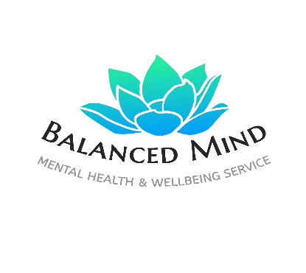
Emotion Colour Map

What it is:
Clients use colours instead of words to represent emotions.

How to do it:
- Draw a blank body outline or circle shape
- Assign colours to feelings (e.g. blue = sadness, red = anger)
- Fill in where emotions sit in the body

Prompt:
“Where does this feeling live in you today?”

