T-Shirt Quilts
wequilt.org
We do make Tee-Shirt quilts. Calculating the expense can be cumbersome. We strive to take that out of your T-Quilt or Memory Quilt Search. Your finished product is of quality materials and skillfully crafted.
The quilts we make use quality quilting cotton for borders, sashing, backing and "fill Blocks", as well as quality stabilizer and batting. If for any reason the number of T’s you have does not allow for the finished quilt to be a square or rectangle block(s) will be crafted to accommodate the quilts’ completion and form.
We ask that all T-Shirts supplied be complete and uncut. We will cut to size.
Each T is pressed and stabilized before they are sewn into the layout approved by the individual requesting the quilt. Approval of layout can be via text, email or in person.
Each quilt will be completed with a simple "meander" quilting pattern and bound. The binding is attached by machine and hand sewn finished.
To easily calculate your expense, you need to multiply the number of T's by $35. If a "fill block" is required, it too would be $35. With the one exception listed below...Your T's. We supply all other materials needed to complete your T-Shirt quilt.
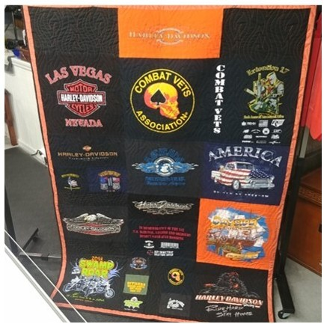
If a different 'longarm (edge 2 edge) quilting patten' is chosen instead of the standard meander it adds $.015 per square inch to final cost. Ex: 60X80 Quilt would be an additional $72.00.

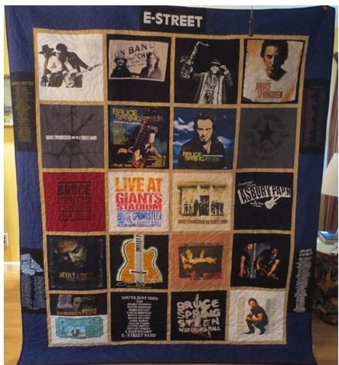
20 T-Blocks 20X$30+$600

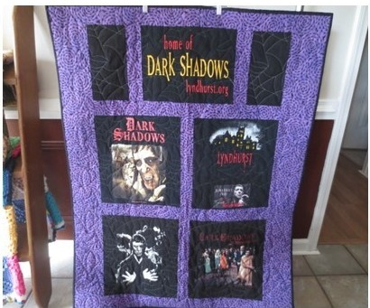
13 T-Blocks and 2 Fill 15 X $30=$450.00

Our goal is to provide you with a qual­ ity quilt that expresses your memories and love of events, activities, family, friends, and the things in your life that were and are memorable.

5 T-Blocks 1 Fill Block (halved) 6X$30=$180

