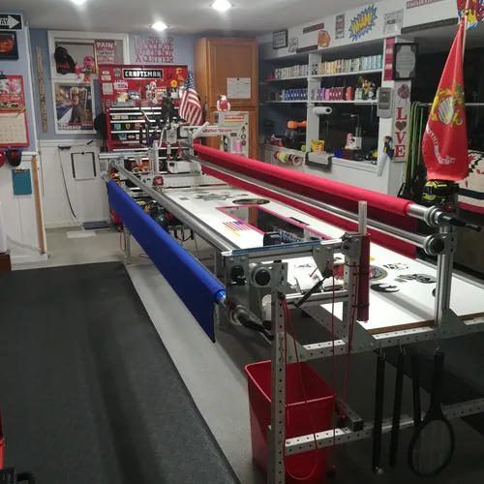
WE QUILT LLC // Les & Elaine Page
1 Pawtucket Rd
West Grove, PA 19390
(Close to State Rd & PA 896 Newark Rd in New London Twp)

i.longarm@yahoo.com
elaine.navarro-page@hotmail.com
www.wequilt.org

Les 757 376-1237 (thee Leatherneck Kilted Quilter)
Elaine 757 376-1238

We operate a hand guided Innova Longarm using the Innova Panto Vision T2 Pantograph Pattern System.
Beginning January 21, 2026
Longarm Fee is based on per square inch calculation for labor - batting supplied at no cost.
T-Shirt Meander | $.0225 For tops not exceeding 102” in length
All Over Edge to Edge & Border to Border Pantographs | $.0250 For tops not exceeding 102” in length
Complex Edge to Edge / Tight & busy pattern or multiple patterns | $.0300 For tops not exceeding 102” in length
Custom: Borders and/or Fills/Multiple Patterns or Threads | $.0350+For tops not exceeding 102” in length
Minimum E2E $50.00 / Minimum Custom $75.00 / * Add .0020 for tops 107”-124” MAXIMUM WIDTH.
For small projects, table runners, wall hangings etc. If delivered with one or more non-minimum projects minimum fee is waived. Small Project is then calculated per square inch and added to total due.
We Quilt LLC highly recommend battingsupersale.com for packaged batting.
Batting: Stocked is supplied by We Quilt  Hobbs Cotton/Poly Blend Batting: 80/20 // 96”// 108” | If you prefer a batting alternative, please pre order and deliver with quilt.
There are many brand alternatives and blends // Black 80/20  Polyester Batting, 100% cotton-all natural or bleached. | Supplying batting needs over 108” is subject to cost plus PA sales tax at 6%
Wool Batting as well. Hobbs 80/20 96”&108” is our stock batting. | We will order at your request
Binding Service @ .30 Cents per linear inch*
*Customer Provides Binding Fabric: 2 ½” W x Linear Length of Quilt + 10”
If quilter supplies only fabric for binding add .05 cents per inch
Binding is machine sewn to quilt and hand sewn finished.
EX: 60X80 Quilt 2 ½ X 290” Binding (280” x .30 cents per inch = $84.00)

Backing: | Pressing and Ironing
Quilt Prep:  Ironing or pressing:  Backing Seems should be ½” pressed open and horizontal if possible. Quilt top seams should be pressed flat and any loose or long threads cut/trimmed. The back should be 10” Wider and longer than the Quilt Top. / 5” all around.  PLEASE: ITEMS SHOULD BE IRONED AND PRESSED WHEN DELIVERED. | No charges are applied to touch up tops or backs before loading. I can trim/rip an oversized back. I cannot add to it. If alteration to back is needed, it will be returned to piecer. If desired, I’ll get a quote from Elaine to alter. I don’t sew.
Return Shipping:  UPS (No PO Boxes) USPS (If PO Box) | Return Ship’g We Pay 50%
Embroidered Label’s
Ready Designs with your text $18.00 (4 lines) / Custom Designs $20.00 and up
Once a design is agreed to allow 7 business days for the completion of your label. Multiple labels may require additional time.
We will use your batting if you choose to supply. Our Labor Fee is the same. We provide stocked batting as a thank you
for letting us be a part of your quilting journey. Our per square inch pricing is a labor factor for tops no longer than 102”. Maximum width is 124” Over 102“ long requires batting we don’t stock. We will use your supplied thread. We stock Superior Omni and Omni Variegated. If you desire a pattern we don’t carry, we have 300+ on hand. If your choice is one we can work with we will purchase it at no cost to you. Many patterns are best applied by computerized systems. We are hand guided/pantograph longarmers. We recommend and use urbanelementz.com
The backing should be 10” longer and wider than the Quilt Top. Batting should be at least 6” wider & 10” longer if customer supplies. MINKY backing MUST be at least 10”Longer and Wider. For BEST results Selvage edge(s) should be on left and right of Minky. NOT top and bottom.
* Larger tops (107”- 124” wide) require extra handling & equipment changes.

