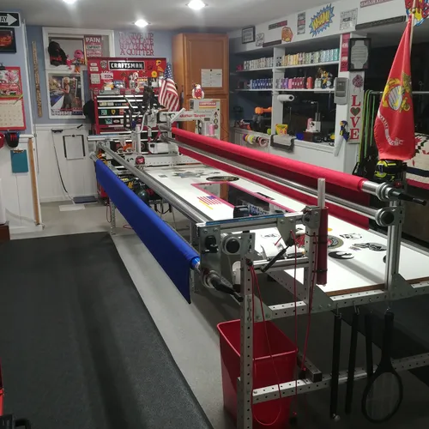

**WE QUILT // Les & Elaine Page**

**1 Pawtucket Rd**

**West Grove, PA 19390**

*(Close to State Rd & PA 896 Newark Rd in New London Twp)*

[i.longarm@yahoo.com](mailto:i.longarm@yahoo.com)

[elaine.navarro-page@hotmail.com](mailto:elaine.navarro-page@hotmail.com)

***www.wequilt.org***

Les 757 376-1237 (*thee Leatherneck Kilted Quilter*)

Elaine 757 376-1238

We operate a hand guided Innova Longarm using the Innova Panto Vision T2 Pantograph Pattern System.

2020 AGAIN / Beginning January 21, 2025

**Longarm Quilting Fees**

|  |  |
| --- | --- |
| T-Shirt Meander | $.0175/sq. inch .0195 / 106”-124”) |
| All Over Edge to Edge & Border to Border Pantographs | $.0200/sq. inch - .0220 / ( “ ) |
| Complex Edge to Edge / Tight & busy pattern or multiple patterns | $.0250/sq. inch - .0270 / ( “ ) |
| Custom: Borders and/or Fills/Multiple Patterns or Threads | $.0300+/sq. inch - .0320+ ( “ ) |

***Minimum E2E $40.00 / Minimum Custom $75.00* / *\* Add .0020 for tops 106”-124” MAXIMUM WIDTH.***

⬇***There is a charge 0f $6.00 per quilt for Variegated Thread***⬇

**Packaged Batting Charges are based on battingsupersale.com.**

|  |  |
| --- | --- |
| **Batting:**  Cotton/Poly Batting: 80/20// 96” & 108”: In stock rolls (Hobbs) | 96” .25 cents // 108” .30 per linear inch |
| Polyester Batting & 80/20 Black | Replacement Cost + 15% |
| 100% Cotton: Natural & Bleached | Replacement Cost + 15% |
| Wool Batting | Replacement Cost + 15% |

**If our batting pricing is reduced, we will pass on the cost savings**

**Binding Service @ .30 Cents per linear inch\***

**\*Customer Provides Binding Fabric: 2 ½” W x Linear Length of Quilt + 10”**

**If quilter supplies only fabric for binding add .05 cents per inch**

**Binding is machine sewn to quilt and hand sewn finished.**

**EX: 60X80 Quilt 2 ½ X 290” Binding (280” x .30 cents per inch = $84.00)**

|  |  |
| --- | --- |
| **Backing:** | **Supplied by Topper** |
| **Quilt Prep:**  Ironing or pressing:  Backing Seems should be ½” pressed open and ***horizontal if possible***. Quilt top seams should be pressed flat and **any loose or long threads cut/trimmed.** ***The back should be 10” Wider and longer than the Quilt Top. 5” all around.*** | ***Items should be ironed and***  ***pressed*** when delivered.  No charges are applied to touch up tops or backs before loading on longarm. |
| ***Return Shipping:***  UPS (No PO Boxes) USPS (If PO Box) | ***Return Ship’g We Pay 50%*** |
| **Embroidered Label’s**  **Ready Designs with your text $18.00 (4 lines) / Custom Designs $20.00 and up**  **Once a design is agreed to allow 7 business days for the completion of your label. Multiple labels may require additional time.** | |

* We will use your batting if you choose to supply.
* We will use your thread if you choose to supply. We stock Superior Omni and Omni Variegated.
* If we don’t have the pattern selected for your quilt we will purchase it at no charge to you. If we are unable to work with that pattern (many patterns are designed for computer systems) we will inform you and assist you in choosing a pattern we can work with. We have over 350 in our current library. We recommend urbanelementz.com
* **The backing should be 10” longer and wider than the Quilt Top. Batting should be at least 6” wider & 10 “longer if customer supplies. *MINKY backing MUST be at least 10”Longer and Wider. For BEST results Selvage edge(s) should be on left and right of Minky. NOT top and bottom.***

**\* Larger tops (106”- 124” wide) require extra handling & equipment changes.**

* ***If you are submitting a Quilt of Valor, there is no longarming charges and we will supply the batting, backing and label from our QOV stock.***