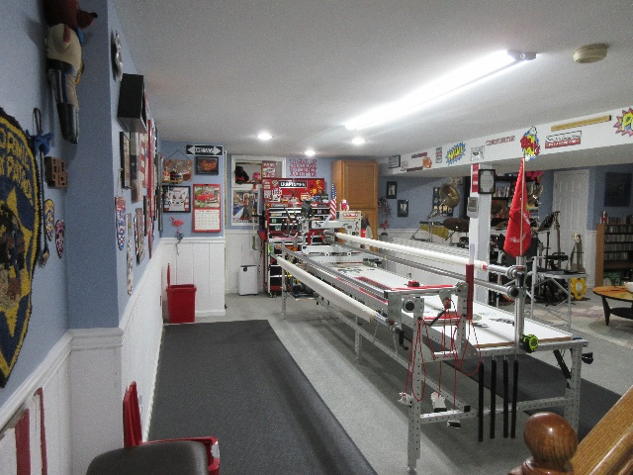
Les & Elaine Page
1 Pawtucket Rd
West Grove, PA 19390
(Close to State Rd & PA 896 Newark Rd in New London Twp)

i.longarm@yahoo.com
elaine.navarro-page@hotmail.com

www.wequilt.org

Les 757 376-1237 (thee Leatherneck Kilted Quilter)
Elaine 757 376-1238 (Coordinator of Not Forgotten QOV)

We operate a hand guided Innova Longarm using the Innova Panto Vision T2 Pantograph Pattern System.
Price List / 2022
Longarm Quilting Fees (per square inch)
T-Shirt Meander | $.0175 /sq. inch - .0195
Edge to Edge & Border to Border Pantographs | $.0200/sq. inch - .0220
Complex Edge to Edge / Usually a tight & busy pattern | $.0250 /sq. inch - .0270
Custom: Borders and/or Fills/Multiple Patterns or Threads | $.0300 & up /sq. inch - .0320+
Minimum E2E $40.00 / Minimum Custom $75.00 / * Add .0020 for tops 102”-124” MAXIMUM WIDTH.
⬇There is a charge 0f $6.00 per quilt for Variegated Thread⬇
Packaged Batting Charges are based on battingsupersale.com at time of purchase.
Batting:  Cotton/Poly Batting: 80/20: In stock rolls (Hobbs) | $5.25/yd
Polyester Batting & 80/20 Black | Our Cost
100% Cotton: Natural & Bleached | Our Cost
Wool Batting | Our Cost

Backing: | Supplied by Topper
Quilt Prep:  Ironing or pressing:  Backing Seems should be ½” pressed open and horizontal if possible. Quilt top seems should be pressed flat and any loose or long threads cut/trimmed. Back should be 10” Wider and longer than the Quilt Top. 5” all around. | Items should be ironed and  pressed when delivered.  No charges are applied to touch up tops or backs before loading on longarm.
Return Shipping:  UPS/USPS | Our Cost
Embroidered Label’s
Standard Label’s $15.00 /// Custom Labels $17.00 and up

- We will use your batting if you choose to supply.
- We will use your thread if you choose to supply.
- If you are submitting a Quilt of Valor, there is no longarming charges and we will supply the batting, backing and label from our QOV stock.
- If we don’t have the pattern you select for your quilt we will purchase at no charge to the customer. If we are unable to work with that pattern (many digital patterns are designed for computer operated systems) we will inform you and assist you in choosing a pattern we can work with. We have over 200 in our current library.
- Backing should be 10” longer and wider than the Quilt Top. Batting should be at least 6” wider & longer if customer supplies.
* Larger tops (102”- 124” wide) require extra handling & equipment changes.

