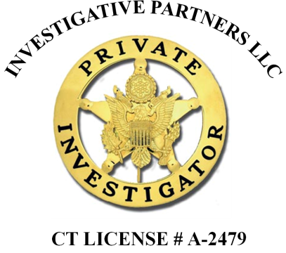**Investigative Partners**

871 Newfield Street, Suite G, Middletown, CT 06457

Phone (860) 613-0563

www.investigativepartners.com

**CURRICULUM VITAE**

**Richard A. Siena**

**Summary of Qualifications**

**EDUCATION**

**WALDEN UNIVERSITY - 2023**

Minneapolis, Minnesota

Master of Science in Criminal Justice (Honors)

**CHARTER OAK STATE COLLEGE- 2020**

New Britain, Connecticut

Bachelor of Science in Criminal Justice (Honors)

**MIDDLESEX COMMUNITY COLLEGE- 2019**

Middletown, Connecticut

Associate of Science in Criminal Justice (Honors)

**CONNECTICUT POLICE ACADEMY- 1983**

Meriden, Connecticut

Municipal Police Certification

**PROFESSIONAL CERTIFICATIONS/LICENSES**

**CONNECTICUT PRIVATE INVESTIGATION AGENCY LICENSE- 2008**

License #: A-2479

**FLORIDA PRIVATE INVESTIGATOR LICENSE- 2022**

License #: C-3200451

**CONNECTICUT SECURITY LICENSE INSTRUCTOR- 2009**

License #: 09-0266

**CPR/FIRST AID INSTRUCTOR- 2010**

American Heart Association and American Safety & Health Institute

**WEAPONS AND TACTICAL INSTRUCTOR- 2015**

Personal Protection Consultants

**SPECIAL WEAPONS AND TACTICS (SWAT) TEAM MEMBER- 1990**

Federal Bureau of Investigation

**CRISIS (HOSTAGE) NEGOTIATION TEAM COMMANDER- 2000**

Federal Bureau of Investigation

**EMERGENCY MEDICAL TECHNICIAN- 1983**

State of Connecticut Office of Emergency Services

**ARNOLD MARKLE CRIMINAL JUSTICE SCHOOL- 2005**

Connecticut Police Academy

**HOMICIDE INVESTIGATION SCHOOL- 2002**

Federal Bureau of Investigation

**ADVANCED MOTOR VEHICLE ACCIDENT INVESTIGATION SCHOOL- 2000**

Northern Florida Institute of Investigations

**PROFESSIONAL EXPERIENCE**

**PRIVATE INVESTIGATOR- 2008**

Owner

Investigative Partners LLC, Middletown Connecticut

**SECURITY/ SAFETY INSTRUCTOR- 2009**

Owner

CT. Safety & Security Training Company Middletown, Connecticut

**COLLEGE INSTRUCTOR- 2012**

Connecticut College System

**SECURITY LICENSE INSTRUCTOR- 2009**

Connecticut Department of Public Safety

**LOSS PREVENTION MANAGER- 1999-2005**

Pelton’s Pharmacy, Middletown, Connecticut

**POLICE- MIDDLETOWN, CONNECTICUT- 1985-2008**

Lieutenant

**POLICE- MIDDLEFIELD, CONNECTICUT- 1982-1985**

Patrol Officer

**PROFESSIONAL ASSOCIATIONS**

Connecticut Association of Licensed Private Investigators

Connecticut Private Investigators Association

Florida Association of Private Investigators

Florida Association of Licensed Investigators

National Council of Investigation and Security Services

National Defense Investigator Association

Licensed Private Detective Association of Rhode Island

Licensed Private Detective Association of Massachusetts

Middlesex County Chamber of Commerce

Old Saybrook Chamber of Commerce

Connecticut River Valley Chamber of Commerce

Connecticut Business Hall of Fame

Police Association of Connecticut

Middletown Police Alumni Association

Middletown Police Benevolent Association

Hartford Chapter of The Fraternal Order of Police

Italian Officers Association of Hartford, Connecticut

Connecticut Bar Association

National Association of Legal Investigators

World Association of Detectives

Espionage Research Institute International

**ADDITIONAL BACKGROUND**

Experienced criminal and civil investigator, death investigations, habeas corpus investigations, motor vehicle accident investigations, service of subpoenas, recognized for expert testimony in federal and state courts on police and security practices, obtains affidavits of no insurance, notarized witness statements, computer/cellphone forensics, video/photo evidence, drone footage, executive protection (body guard), technical surveillance counter measures (locating covert cameras, audio devices, and tracking devices), court testimony, surveillance, and additional services.

Rev. 4/17/23