**Soil Health for Gardens**

By Dean Winward - Southern Utah University – Agriculture Program

Gardening in southern Utah comes with its own set of problems and many of those are associated with our soils. Following is a list of some of the issues we have and what can be done to remedy those problems. Some basic information is provided to help with understanding the solution to the problem.

**Soil texture**

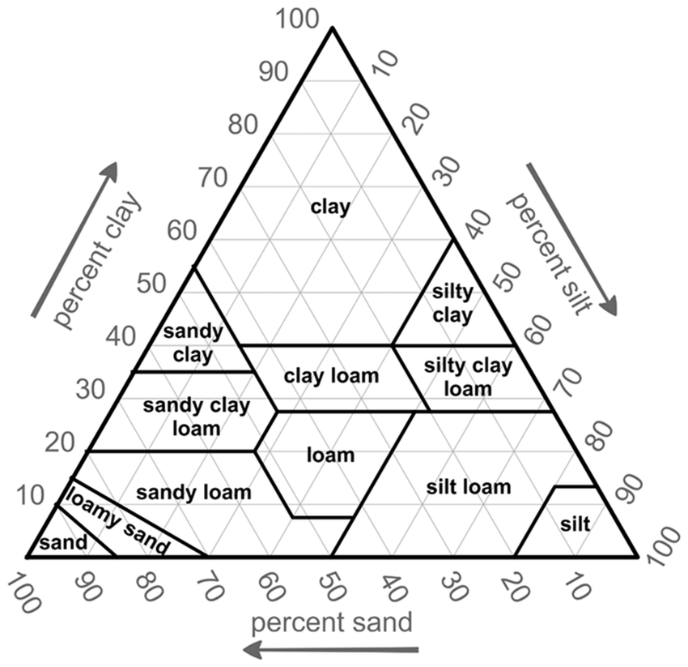

A loam textured soil is made up of relatively equal properties of sand, silt and clay and is generally the most favorable. The extremes of sand and clay can create unique problems. The best solution to both is to add organic matter.

**Compaction**

Tilling the soil when it is too wet can ruin the soil structure and then make it difficult to correct. Wait until the soil is dry enough to work it into a mellow seedbed. Adding organic matter can help reduce compaction.

**pH**

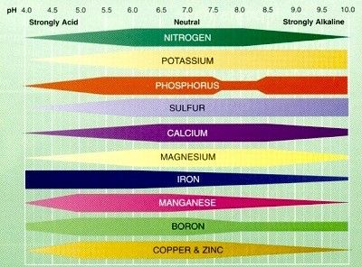

A pH of 7 is considered a neutral pH. Most of our soils are above 7. As is seen on the above graph, pH can affect the availability of plant nutrients. Soil pH is very difficult to change but once again, adding organic matter can help make it more favorable.

**Salinity**

Some of our soils may have high enough salt contents to affect plant growth. Electrical Conductivities (EC) above 2 ds/m may start to damage sensitive crops. The 2 main salts we have in our soils are sodium (creating sodic soils) and calcium (creating saline soils). Adding gypsum can help correct a sodic soil but can make a saline soil worse. Guess what – adding organic matter can help reduce the problem. Be careful however, many sources of organic material can be high in salts, i.e. fresh manure, some potting mixes, biosolids, etc.

**Fertility**

How do you know what conditions you have in your soil and what nutrients are needed? The best way is to do a soil test. Taking a proper soil test and having it analyzed (contact your local extension agent for details) can help take the guesswork and frustration out of your gardening.

Also knowing what part of the plant you intend to harvest can help customize your fertilizer needs. Plants grown for their vegetative parts (leaves, stems, etc.) will need more nitrogen. Those grown for their reproductive parts (fruits, seeds, flowers, etc.) and roots will need more phosphorus.

One of the ironies about living in our red, iron-rich soils of Iron County is that much of the iron is tied up and not available, thus creating iron deficiencies in several of our crops. The solution is to use a chelated (pronounced “key-lated”) form of iron or grow plants that are not sensitive to iron deficiency. Chelated iron is expensive so make sure to follow the directions in how much to apply. It works best when applied just as the plants are starting to grow in the spring.

**Organic matter**

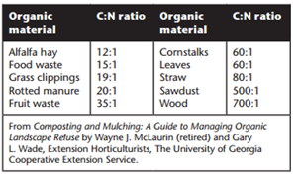

Much credit has been given to the importance of adding organic matter to the garden soil. However, the stage of decomposition of that organic matter can be important to knowing when to apply it. Humus is organic matter decomposed beyond recognition and can be added to the soil at almost any time without creating a problem. Litter on the other hand, is undecomposed organic matter and depending on its Carbon/Nitrogen ratio, may cause the reduction of nitrogen levels in the soil to the point of creating a nitrogen deficiency. Microbe numbers increase in response to the increased supply of food and consume any available nitrogen before the plants can get it. Thus, the higher the ratio the greater the greater the chance of nitrogen deficiency. When the microbes run out of food, they die, releasing the nitrogen back to the soil. It is generally best to apply litter in the fall so these conversions take place during the winter and not during the growing season.

**Conclusion**

Knowing these relationships about the soil can help you be more successful in your gardening endeavors. Consult your local nursery specialists about specific products that can help you achieve your gardening goals.

**References:**

Preparing Garden Soil by Duane Hatch, USU Extension Horticulturist, HORTICULTURE FACT SHEET 01

<https://extension.usu.edu/yardandgarden/ou-files/HG_H_01.pdf>

Preparing and Improving Garden Soil by Katie Wagner, USU Extension Horticulture Faculty Salt Lake County, Larry Sagers, Horticulture Specialist USU Extension, Horticulture/Soil/2012-01pr

<https://digitalcommons.usu.edu/cgi/viewcontent.cgi?article=2067&context=extension_curall>

Composting by Joseph Masabni, Texas A&M Extension

<https://agrilifeextension.tamu.edu/library/gardening/composting/>