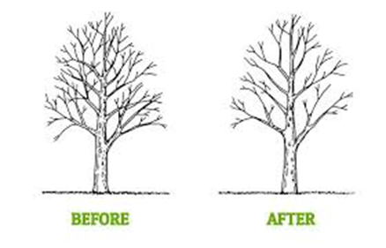**TEN BASICS OF WHEN AND HOW TO PRUNE FRUIT TREES**

by Dean Winward – SUU - Agriculture Program

1. Use good quality, sharp tools. Bypass shears are generally preferred to anvil type shears. Disinfect tools after cutting diseased branches to prevent spread to other trees.

2. The best time to prune fruit trees is when the tree is dormant (before leaf growth in the spring). Early summer pruning can be used to slow down overly vigorous trees or trees that are too large.

3. New trees: cut back to 24 to 34 inches high and cut any side shoots remaining below that to 1-2 buds. This will encourage branching and equalizes growth between the top and the root system. Also, when planting, point the lowest branch on the tree to the southwest to help reduce winter frost damage to the trunk.

4. Young trees should have their fruit removed the first few years to put energy into the root system and tree growth. Use this time to train the tree and to develop strong branches. Vigorous growing, young trees can be trained with branch bending which can minimize pruning and encourage the tree to fruit earlier.

5. Remove dead, diseased or broken branches. Remove suckers, water sprouts and crossing branches (see figure 1).

6. For most fruit trees, flower buds for the new season’s crop were formed last summer so don’t cut them all off. Generally vertical branches are vegetative (no fruit) and vigorous and can create weak crotch angles. Horizontal branches typically produce more fruit and allows the fruit to hang without rubbing other fruit or limbs. A combination of the two is necessary for balancing growth, fruiting and strong crotches. Branches bent from 45o to 60o angles to the trunk will help accomplish this.

7. There are 3 types of pruning cuts: heading, thinning and bench (see fig. 2). Each have their own purpose. Heading cuts remove the terminal end of a shoot. Heading into 1-year old wood will invigorate growth behind the cut, heading into 2-year old wood will slow down vigorous growth. Thinning cuts remove the limb back to its point of origin. This is the preferred cut to maintain tree size and shape since it doesn’t have the invigorating effect of the other cuts. Bench cuts are used to encourage outward growth of the tree but can cause a weak attachment of the branch just below the cut so should be used sparingly.

8. Make clean cuts (within ¼”) of a bud; don’t leave stubs or shredded cuts.

9. Prune to optimize light penetration into the tree. Stagger where the branches come off the tree around the trunk to eliminate shading caused by closely spaced, parallel branches. Leaves exposed to the sun produce more and larger fruit. Prune more in the top of the tree so that the lower branches are exposed to sunlight.

10. Peaches and nectarine grow a lot, so remove at least 30% of last years’ growth. For cherry, apple, pear, plum, and apricot which bear on spurs or less vigorous shoots, remove about 20% of last years’ growth.

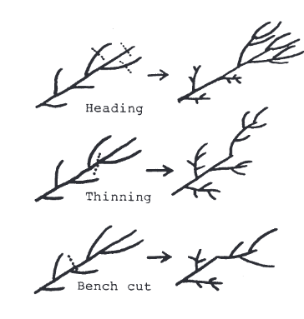 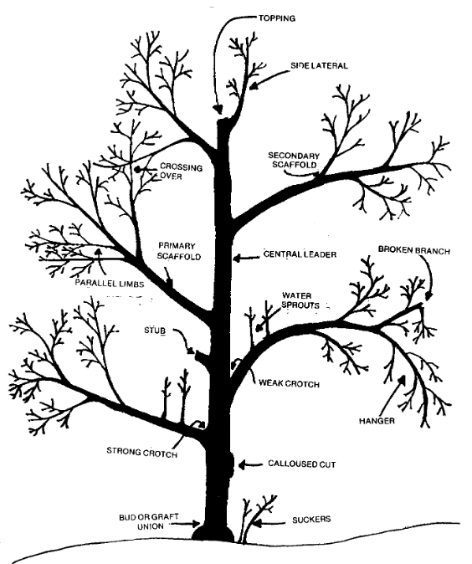

Fig. 1 Fig. 2

**References & Additional resources:**

**Pruning the Orchard** by Ronald H. Walser, Wilford A. Wright, Alvin R. Hamson, Extension Horticulturists, Utah State University Revised March 1994 by Dan Drost, Extension Vegetable Specialist, and Tony Hatch, Extension Horticulture Specialist March 1994

<https://digitalcommons.usu.edu/cgi/viewcontent.cgi?article=1724&context=extension_histall>

**Pruning Fruit Trees: Clip with Confidence!**

<https://extension.usu.edu/yardandgarden/ou-files/PruningHandout-OY-Mar2017.pdf>

**Training and Pruning Apple Trees** by R. P. Marini, Extension Specialist, Horticulture, Virginia Tech

<https://www.pubs.ext.vt.edu/content/dam/pubs_ext_vt_edu/422/422-021/422-021_pdf.pdf>