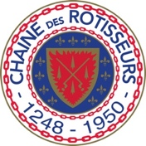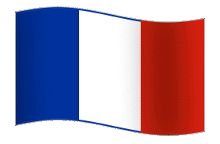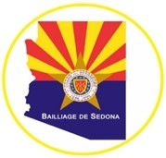

Sedona Bailliage, Confrerie de la Chaîne des Rôtisseurs
Invites You to a Bastille Day Celebration and Inductions/Reinstatements
Monday, July 14, 2024
Rene Tlaquepaque
6-9 pm
RECEPTION
French 75 / Plus Featured Non-Alcohol Reception Cocktail
Tray plated hors d’oeuvres in the bar
Lobster Salad Tartlets’, Graved Lox, Crème Fraiche & Caviar, Roasted Lamb Loin, Orange Marmolade, Sanoma Goat Cheese & Boursin Cheese Gougères
Family Style, placed on each table
Pate Maison with Rene Bread Service
Domaine Serge LaPorte Sancerre 2023/ Plus Featured Non-Alcohol Cocktail No. 2
Cold Cucumber Soup with King Crab
Main Course Choose one
Coquilles St. Jacques
Scallops on the half shell, shrimp, Dauphine potatoes, mushrooms, Cognac, Gruyere cheese sauce
Jean-Louis Mothe Chablis 2023 / Plus Featured Non-Alcohol Cocktail No. 3
Or
Chicken “Poulet Veronique”
Organic chicken cutlets, lemon, shallot, white grape pan sauce, tarragon, toasted almonds
Domaine Maison Champe Beaune Pinot Noir 2018 / Plus Featured Non-Alcohol Cocktail No. 4
Apple Tart Tatin w/ Vanilla Bean Gelato
Chateau Suduiraut Sauternes 2021 $7.00 pp / Plus Featured Non-Alcohol Dessert Cocktail

Parting Gift (packaged to-go cookies) on the bar

