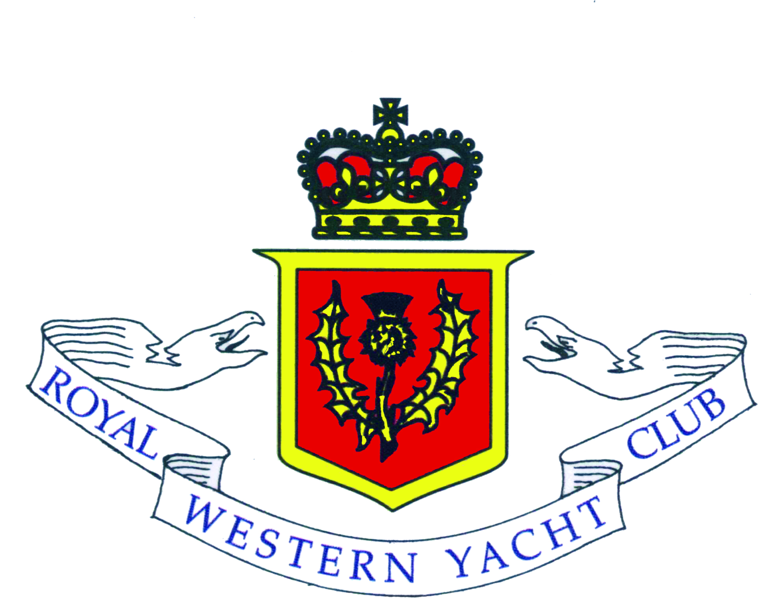

APPLICATION FOR MEMBERSHIP

Name of Applicant (Please write in block capitals)
Title (Mr., Mrs., Miss, etc.)...........................
Full Name……………………………………………………………………………………………………………..
Address...........................................................................................................................................................
.........................................................................................................................................................................
Post Code..................................Tel No...........................................Email……………………………………..

Date of Birth (If under 21).......................................
Yacht Clubs of which Applicant is already a Member……………..............................................................

Brief sailing history of Applicant…………………………..............................................................................
......................................................................................................................................................................................................................................................................................................................................................
Are any of your relations already members of the RWYC? (If yes, please state name and relationship).....................................................................................................................................................
Are you a boat owner? (If yes, please give details)
..........................................................................................................................................................................
Signature of Applicant...................................................................................................................................

Proposed for Membership (Name in block capitals)...................................................................................
(Signature)................................................................................................
Remarks...........................................................................................................................................................
Seconded for Membership (Name in block capitals)..................................................................................
(Signature).................................................................................................
Remarks...........................................................................................................................................................
Application Dated............................................................................................................................................

Completed Applications for Membership should be sent to: james@pollockandcochrane.com or:
James Cochrane
Hon. Secretary & Treasurer
Royal Western Yacht Club
Pollock & Cochrane Ltd.,
Rowan Street, Paisley, PA2 6RT
Tel: 0141 889 2009

