  July 27, 2019  Kids Day Out  Free day of Fishing  Country Camo Outdoors along with ODNR, US Fish and Wildlife, and Ohio Sportfish and wildlife restoration is sponsoring a free day of fishing and fishing skills workshops for children. Children will learn the Passport to fishing skills of habitat, knot typing, fishing handling, casting and more and then given the opportunity to put their skills to use on trying to land the big one in Cenci Lake. Lunch will be provided for participants free of charge.  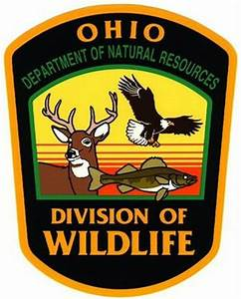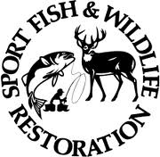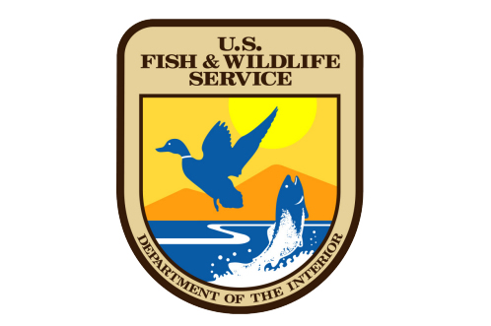 | Country Camo Outdoors  ────  Kids Day Out  ────  Free Food, Fishing and Fun  ────  Cenci Park Lancaster Ohio  ────  10 am -2pm  Country Camo Outdoor  Cenci Park Lancaster Ohio  www.countrycamooutdoors.org  countrycamooutdoors@gmail.com  July 27, 2019

